
Let us join together to remember Pentecost. Why not share and learn together with your family.

Leader: May the Lord be with you!
Response: And also with you
Leader: Jesus Christ is the light of the world.
Response: The light shines in the darkness, but the darkness has not overcome it.
On Sunday it was Pentecost Sunday. Pentecost is like a birthday for the Church.
(By church I mean the people who are followers of Jesus, not the building)
Maybe you had a birthday whilst school has been closed. Happy belated birthday to you!
Maybe you felt sad you couldn’t have a party with your family and friends. Hopefully you can celebrate together soon, until then we are still in a time of waiting.
Just before Jesus went to be in heaven and after he rose from the dead, Jesus told his disciples to wait in Jerusalem for a gift from God. They were scared and puzzled by what they had seen. They missed their friend Jesus and felt sad and alone. So they met together in a room and waited.
I’m feeling puzzled by my lamp - why won’t it work?
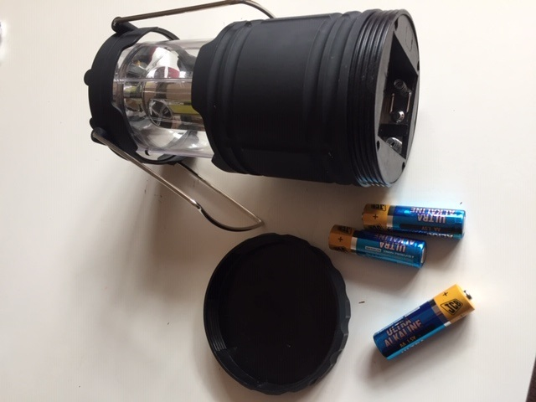
Oh I’m missing the batteries! It needs the batteries to give it power!
Choose a link to find out what happened. You can read the story in a bible in the book of Acts chapter 1 and 2.
https://m.youtube.com/watch?v=xtokHQOmFu0&feature=youtu.be
https://m.youtube.com/watch?feature=youtu.be&v=IqG_lvZhU-A
https://m.youtube.com/watch?v=OMQKy1Mx49M
It was the Holy Spirit that came upon the disciples with flames of fire and wind. He gave them “power” and help, a bit like my lamp needed power from the batteries.
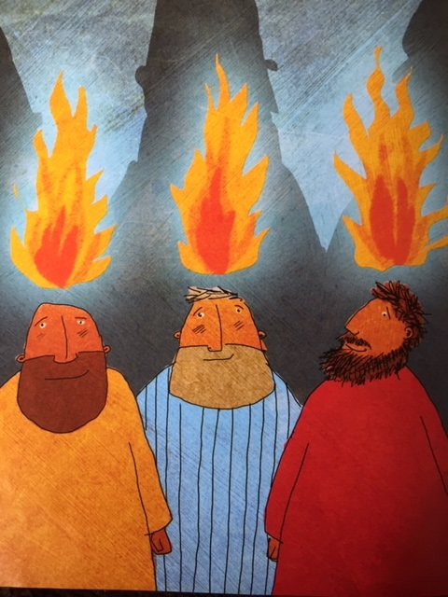
Because of the Holy Spirit, on that day 3000 people became followers of Jesus. They then spread out to many parts of the world, still increasing in number to this day. That’s why it’s the churches birthday.
Let’s sing a song - Colours of day
https://m.youtube.com/watch?v=mw-7CJhlbp0
Have a listen to this song too – May the God of Hope
https://m.youtube.com/watch?v=d8IJpiTK9CM
Lets us pray
Thank you God for sending your Spirit. Please be with those who are feeling sad, lonely and puzzled due to the Covid-19 virus. Please give us all a sense of hope and courage to overcome these difficulties.
Fill us all with your love.
Amen

