DT Project 2
Materials
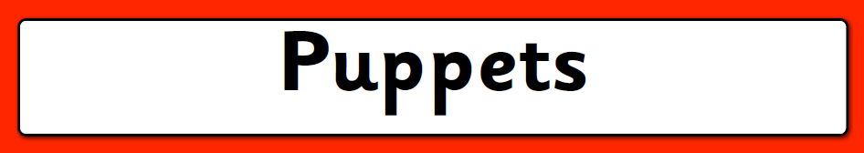

In this unit, I will:

- Investigate a range of puppets and their features
- Work with fabric to create a finger puppet
- Develop and practise sewing skills
- Design a glove puppet
- Follow a design to make a puppet
- Evaluate a finished product

