DT Project 3
Food
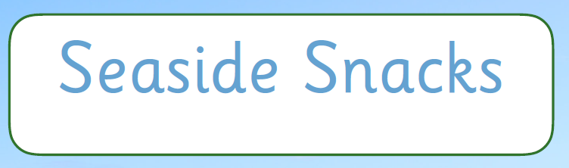

In this unit, I will:

- Follow instructions to make savoury snacks
- Make edible boats
- Make fruit sculptures
- Make edible cake decorations
- Create frozen seaside snacks
- Design a seaside snack

