DT Project 1
Design, Make, Evaluate

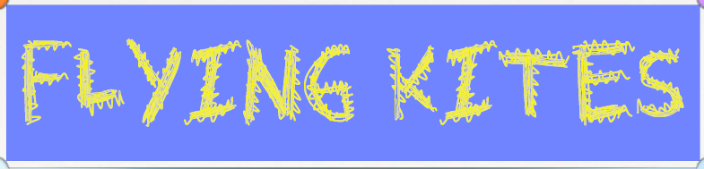

In this unit, I will:

- Explore the history of different kites
- Explore materials used to make simple kites
- Make a simple Carp kite
- Explore designs of diamond kites
- Construct a kite, following a design
- Evaluate a finished kite

