Year 2 English Long Term Plan

 | 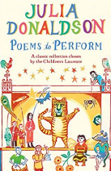  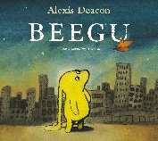  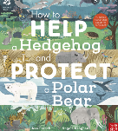  Autumn |  |  | 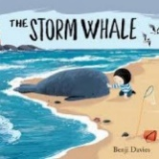  Spring |  |  | Summer
Book | Poems to Perform | Beegu | How to Help a Hedgehog and Protect a Polar-Bear | 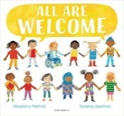  All Are Welcome | The Storm Whale | 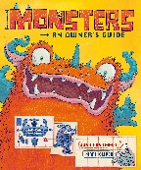  Monsters: An Owners Guide |   If All the World Were… | 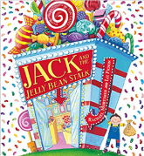  Jack and the Jelly Beanstalk | 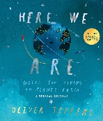  Here We Are
Author | Julia Donaldson | Alexis Deacon | Jess French | Alexandra Penfold | Benji Davies | Jonathan Emmett | Joseph Coelho | Rachael Mortimer | Oliver Jeffers
Genre | Poetry | Fiction | Non-Fiction | Poetry | Fiction | Non-Fiction | Poetry | Fiction | Non-Fiction
Curriculum Links | Personal | Personal | Global | Personal | Global | National | Personal | Global/Personal | Global
Values | Wisdom  Compassion  Peace | Wisdom  Friendship  Compassion | Reverence  Compassion | Reverence  Friendship  Peace/Koinonia | Friendship  Thankfulness  Compassion | Compassion  Forgiveness | Trust  Reverence  Peace | Wisdom  Compassion | Reverence  Thankfulness  Koinonia
Writing | Explore and enjoy poems  Performance poetry  Writing poetry (simile poetry) | Character Descriptions  Writing own version of story  Write a guide to Planet Earth | Non-Chronological report.  Use statements within our writing | Performance Poetry  Write a short poem | Write in-role in the form of a diary entry  Develop empathy | Write a section of an owner’s guide with instructions and explanations. | Short letter writing.  Write a non-narrative poem to be read to an audience. | Character descriptions  Writing an alternative story to a traditional tale | Write a leaflet/guide about how to take care of our planet and the creatures
Grammar | Use adjectives/  explore  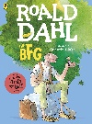  expanded noun phrases and similes to add depth to our writing | Capital letters and full stops  Use expanded noun phrases to describe our character’s appearance and personality.  Use time conjunctions to strengthen our sentences | Use technical and factual language derived from research.  Explore 4 types of sentence with correct punctuation marks.  Past tense verbs. | Use commas to show the need to pause in poetry  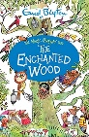  Use statements and exclamations within our writing | Using subordination and coordination to expand and deepen our sentences.  Past/present tense and explore progressive verbs. | Commas in a list  Adding suffixes ‘-ment’ and ‘-ness’ and use adverbs.  Revise and use command sentences. Apostrophes to show singular possession | 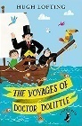  Write statements and commands for the correct purpose whilst using subordination within our letters.  Use expanded noun phrases - | Use all 4 sentence types in our writing. Use questions for effect – correctly use ‘!’ and ‘?’  Use expanded noun phrases and conjunctions | Use of the suffixes –er, –est in adjectives and the use of –ly to turn adjectives into adverbs  Use progressive present tense verbs
Class novel
 | The BFG – Roald Dahl | The BFG – Roald Dahl | The BFG – Roald Dahl | The Enchanted Wood – Enid Blyton | The Enchanted Wood – Enid Blyton | The Enchanted Wood – Enid Blyton | The Voyages of Dr Dootlittle – Hugh Lofting | The Voyages of Dr Dootlittle – Hugh Lofting | The Voyages of Dr Dootlittle – Hugh Lofting
Values | Friendship  Compassion | Friendship  Compassion | Friendship  Compassion | Reverence  Thankfulness | Reverence  Thankfulness | Reverence  Thankfulness | Compassion  Reverence | Compassion  Reverence | Compassion  Reverence

