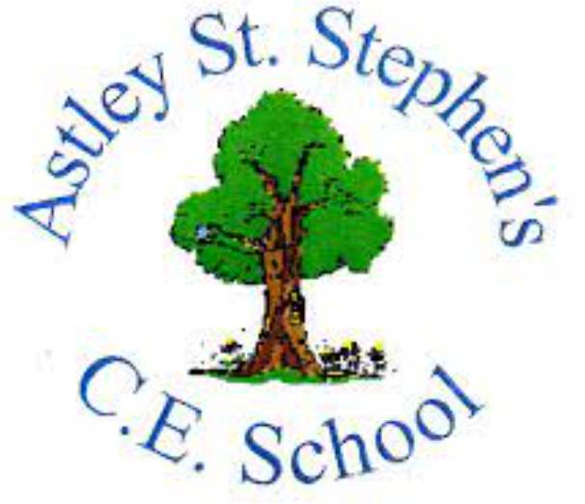 | Art
 | Autumn Term | Year 2 | Area of Study: Textiles
What should I already know?
- Different joining techniques when working with textiles, such as gluing and stitching.
- Some basic sewing skills such as threading a needle, starting a stitch, doing a basic running stitch and ending a stitch.
Key skills
Running Stitch
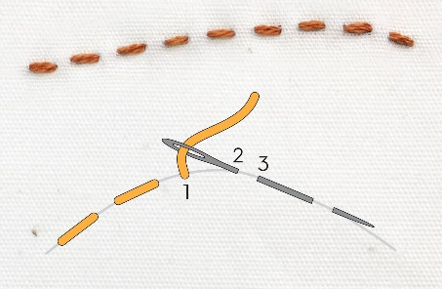

Adding embellishments
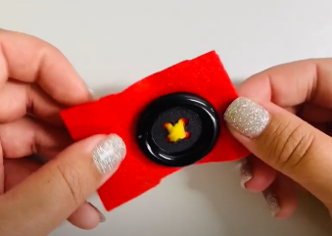
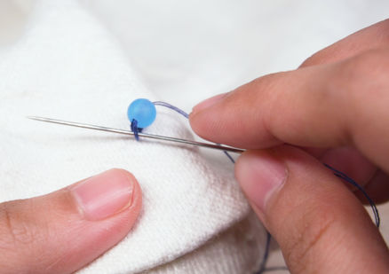
Key Vocabulary
Loom | A device for making fabric by weaving yarn or thread.
Needle | A very fine slender piece of polished metal with a point at one end and a hole for thread at the other used in sewing or weaving
Thread | A long thin strand of cotton or other material used in weaving.
Warp | The vertical threads on a loom.
Weave | To make fabric by interlacing long threads.
Weft | The crosswise threads on a loom that are passed over and under the warp threads to make cloth.

What will I know by the end of the unit?
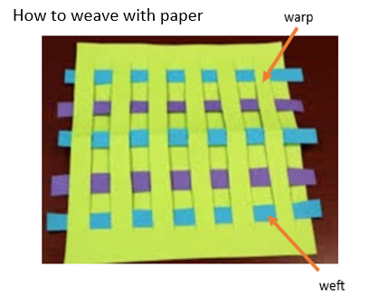

How to weave with ribbon
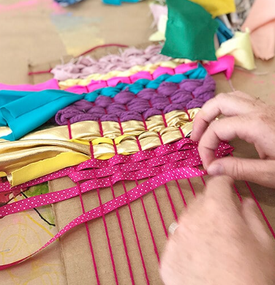

Artist: Merry Havens
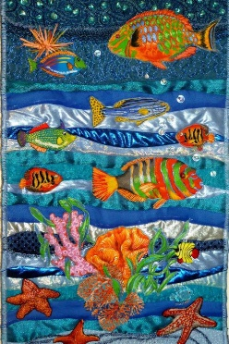
- Merry is from Thornton, Colorado
- Merry is a Science Teacher and creates art for fun
- She is a quilting artist
- She adds decorative cut work appliques, decorative threads and yarns and real hand painted stones to give an extra element of colour and texture

