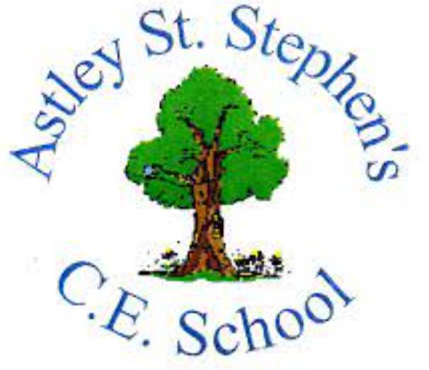 | Art
 | Summer Term | Year 2 | Area of Study: Clay
What should I already know?
• Play-doh can be shaped with our hands or we can use tools to shape and cut it
- Objects can be pressed into play-doh to create patterns and texture
- Clay is similar to play-doh but it dries very hard
- I can use tools on clay to shape it
Key skills
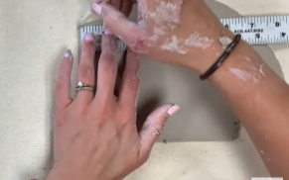
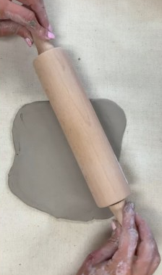
How to roll and cut a slab of clay:
How to roll a coil:
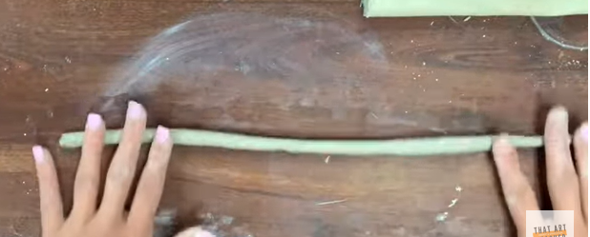
How to create a clay tile and add additional clay on top. To attach clay you need to score and slip
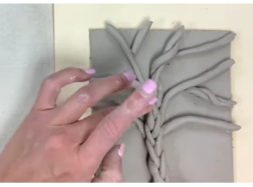

Key Vocabulary
Clay | A natural material made up of tiny pieces of rock, it hardens as it dries
Coil | A long, thin rope of clay made by rolling is between your hands
Score | Roughly scratching the surface so it can be joined to another piece of clay
Slab | A flat piece of clay made with your hands or a rolling pin
Slip | Mixture of water and clay, used when joining two pieces of clay
Texture | How something looks or feels
Tools | Equipment that you hold in your hand and use

What will I know by the end of the unit?
Adding water to clay makes it softer, but adding too much water makes it unmanageable.
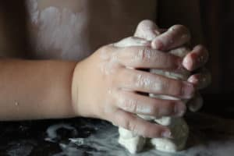

Clay can crack when it dries if it is too thin
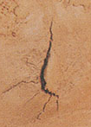
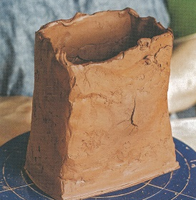

Adding texture to the surface:
Don’t press down to hard, you just want to gently scratch the surface

Artist: Natalie Blake (1970 - )
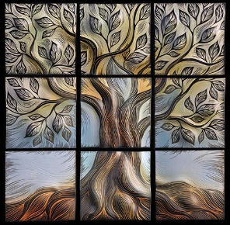

- Natalie is American and lives in Vermount
- She turns flat wall tiles into a three-dimensional sculpture
- Each tile Natalie makes is rolled and sculpted by hand
- She is inspired by water and nature

