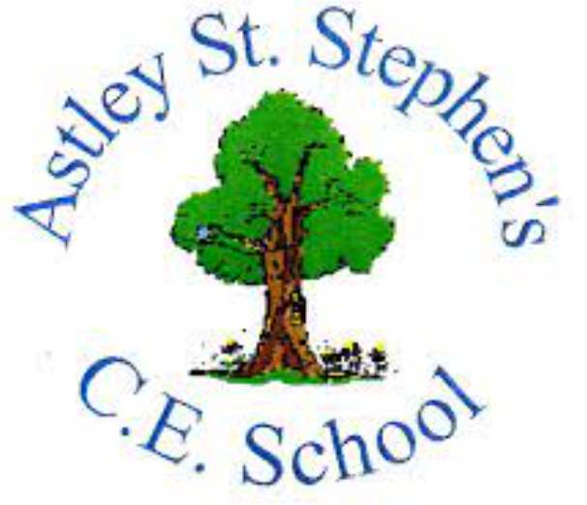 | Art
 | Spring Term | Year 2 | Area of Study: Drawing
What should I already know?
- How to hold my pencil correctly
- A sketch is a rough or unfinished drawing
- Know the names of some of the tools and techniques used
- Pencil shading can be used to create darker and lighter areas on a drawing
Key skills
Make light and dark lines
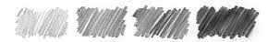
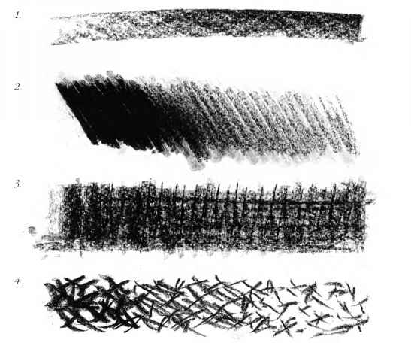
Use other media to draw, including: charcoal
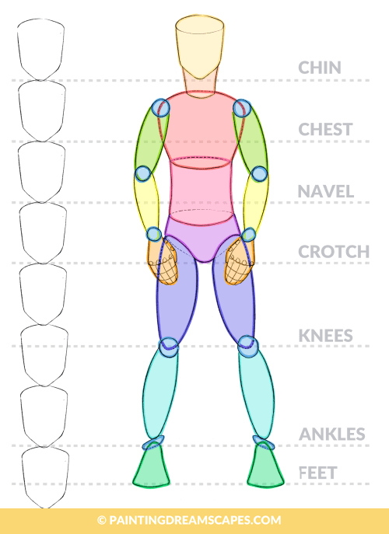

Use body proportions to draw an accurate person

Key Vocabulary
Background | the part of the picture that is furthest away from you
Foreground | the part of the picture that is nearest to you
Mark making | making different patterns, lines and shapes
Perspective | A way of drawing that makes some objects appear closer than others
Proportion | Relative size of parts of a whole
Tone | How light or dark something is

What will I know by the end of the unit?
How to use perspective in artwork
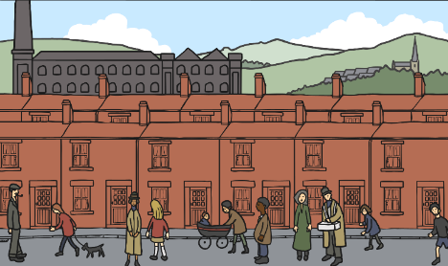

A body is drawn by drawing different shapes.
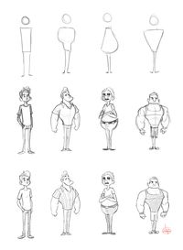

Artist: LS Lowry (1887 - 1976)
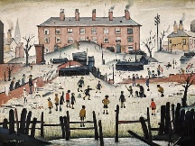
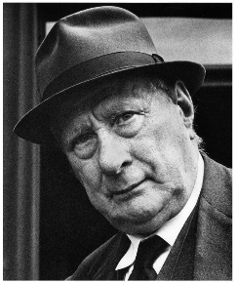
- Laurence Stephen Lowry was an English artist.
- His drawings and paintings mainly show Pendlebury, Lancashire as well as Salford and its area.
- Lowry is famous for painting scenes of life in the industrial districts of North West England
- He used only five colours – flake white, ivory black, vermilion (red), Prussian blue and yellow ochre.

