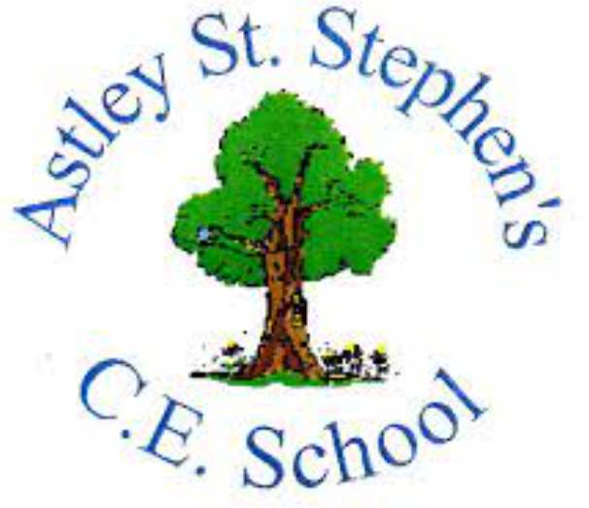 | Art
 | Spring Term | Year 4 | Area of Study: Textiles
What should I already know?
- Basic sewing skills: threading a needle, starting a stitch, doing a basic running stitch and ending a stitch.
- Adding embellishments onto sewing
Key skills
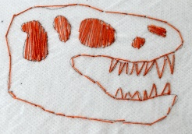
Create a picture using stitches and ‘colour in’ by stitching.

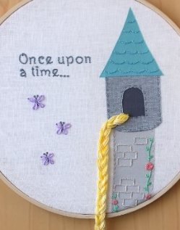
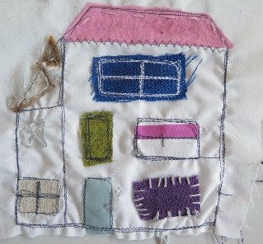
Layering material on top of my base layer to add interest.
Stitch words
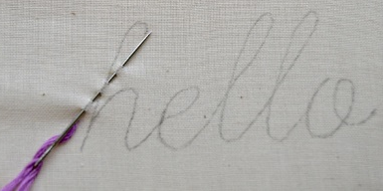

Key Vocabulary
Applique | Decorative needlework in which pieces or patches of fabric in different shapes and patterns are sewn or stuck on fabric piece to form a picture
Embroidery | Decorating fabric or other materials using a needle to apply thread or yarn
Material | Cloth or fabric
Tapestry | Woven decorative fabric, the design of which is built up in the course of weaving
Thread (verb) | To pass a piece of thread (noun) through a hole in the end of the needle.

Artist: The Bayeux Tapestry (1066)
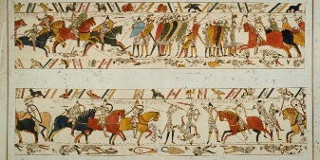
- An embroidered cloth nearly 70m long and 50 tall cm
- Shows the events leading up to the Norman Conquest of England in 1066
- It’s displayed in Bayeux Museum, France
- Consists of 60 scenes, embroidered with woollen thread onto linen.
- The Bayeux Tapestry, despite its name, is not really a tapestry
What will I know by the end of the unit?
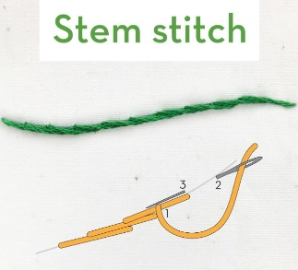
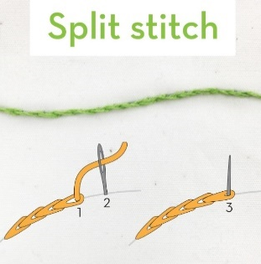
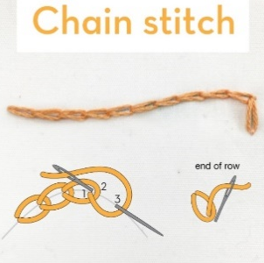
How to sew using different stitches:

