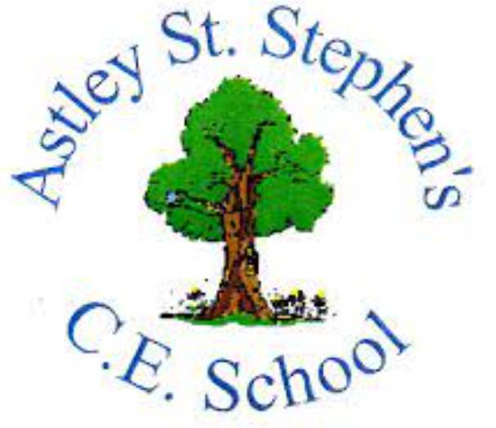 | Art
 | Summer Term | Year 4 | Area of Study: Clay
What should I already know?
• We can use clay to create a range of shapes and objects.
- Roll can clay into a ball and coil
- We can decorate clay items once they have dried.
Key skills
Make an animal using clay by creating a pinch pot, creating the right thickness and adding on extra elements.

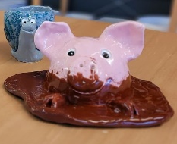
Adding detail by painting once clay has dried
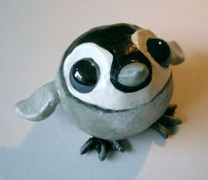
Using PVA ‘glaze’ to add gloss to finished piece.

Key Vocabulary
Clay | A natural material made up of tiny pieces of rock, it hardens as it dries
Glaze | A glassy coating on ceramics/clay
Pinch Pot | A simple form of hand-made pottery produced from ancient times to the present. The method used is to simply have a lob of clay, then pinch it to the shape desired.
Score | Roughly scratching the surface of wet clay so it can be joined to another piece of clay
Slip | A liquid, usually water, added when joining two pieces of clay
Tools | Equipment that you hold in your hand and use.

Artist: Duangkamol Srisukri (1957 - )
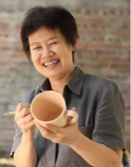
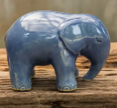
- Born in Bangkok
- Her work is both Thai and Chinese reproductions like vases, ginger jars, and figurines.
- Her intention is to maintain the ancient art of making celadon so that future generations can enjoy these pieces.
- Working with glazes is her favourite art form
What will I know by the end of the unit?
Clay techniques:


Roll into a ball Roll into a coil Carve details using tools

A range of clay tools can be used to create different textures and marks.

Stages of making a pinch pot:
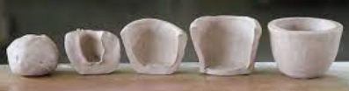
Use water and sponge to smooth the surface.

