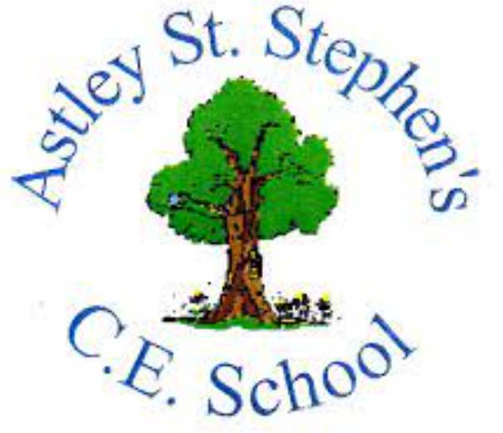 | Art
 | Autumn Term | Year 4 | Area of Study: Drawing
What should I already know?
- A portrait shows what a person looks like.
- A self-portrait is a picture of what you look like.
- Pencil shading can be used to create darker and lighter areas on a drawing.
Key skills
Can use stages of drawing eyes, nose and mouth.

Can use pressure of a pencil to create tone
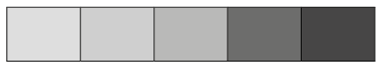
Can share using cross-hatching.
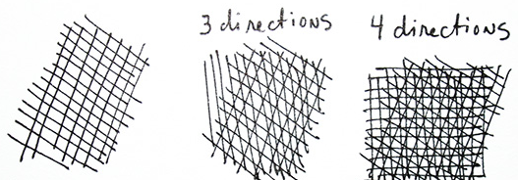
Key Vocabulary
Cross-Hatching | Lines drawn in different directions over the top of one another to create shading
Heavy Pressure | Pushing or pressing down hard with your pencil, to show shade.
Light Pressure | Pushing or pressing down gently with your pencil, to show shade.
Shading | The difference of colour from light to dark.
Tone | How light or dark something is
Portrait | A likeness of somebody, especially their face.
Proportion | A part that makes up a whole

Artist: Frida Kahlo (1907—1954)
- Frida Kahlo is a Mexican artist known for her portraits and self-portraits inspired by nature and Mexican artefacts.
- Frida enjoyed using vibrant colours and mixed fantasy with realism.
- Frida Kahlo is one of the most important artists of modern times. She was famous for painting self-portraits (pictures of herself) but she was particularly famous for painting women as strong people.
- She said that she painted self-portraits because “…I am the person I know best.”
What will I know by the end of the unit?
The proportions of a face:

How to shade with a pencil:

