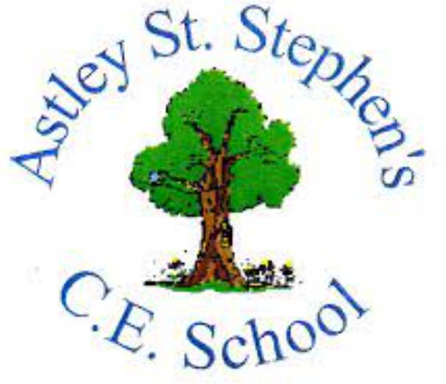 | Art
 | Spring Term | Year 1 | Area of Study: Collage
What should I already know?
- Art can be made in lots of different ways.
- There are lots of different materials and they all have different qualities.
- The form, feel, texture and pattern of objects can be different.
Key skills
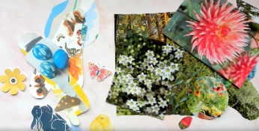
Can sort and group materials based on colour, texture, design, size:

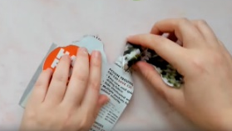
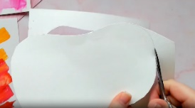
Can tear, rip and cut different materials, to get a different effect on the edges:

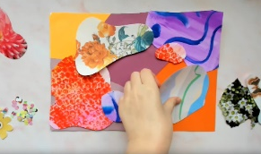
Can think carefully about the way my collage is arranged:

Key Vocabulary
Abstract | art that does not look like something real but uses shapes, colours and marks.
Arrange | The way you place things on your backing
Collage | Art made by sticking different materials on to a backing
Group | To sort materials based on colour/texture/size
Texture | How something feels

What will I know by the end of the unit?
Any material can be used to collage
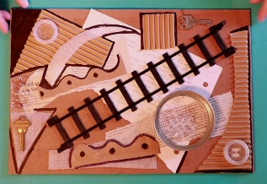

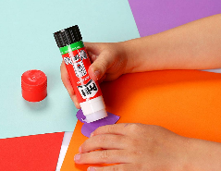
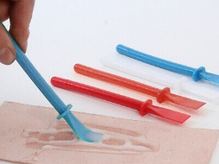
Different materials might need to be stuck in different ways

Art does not have to look perfect or like anything else I have seen before.

Abstract art can represent me!

Artist: Kurt Schwitters (1887 - 1948)
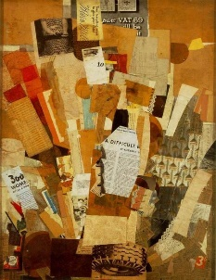
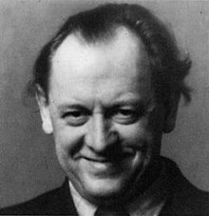
- Kurt Schwitters is from Germany.
- Schwitters uses found rubbish and changes it into something beautiful
- He is most famous for his collages, called "Merz Pictures"

