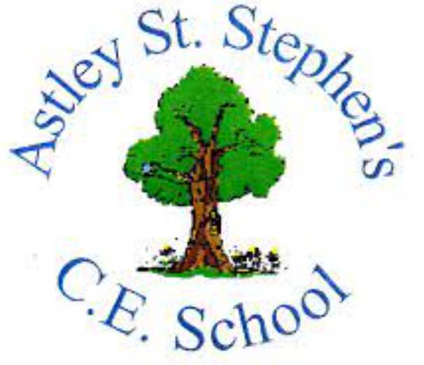 | Art
 | Autumn Term | Year 1 | Area of Study: Painting
What should I already know?
- How to use a paintbrush
- The names of all the colours
- Know the names of some of the tools and techniques used
Key skills
Observational drawing of flowers:
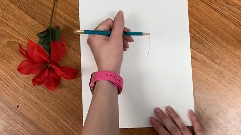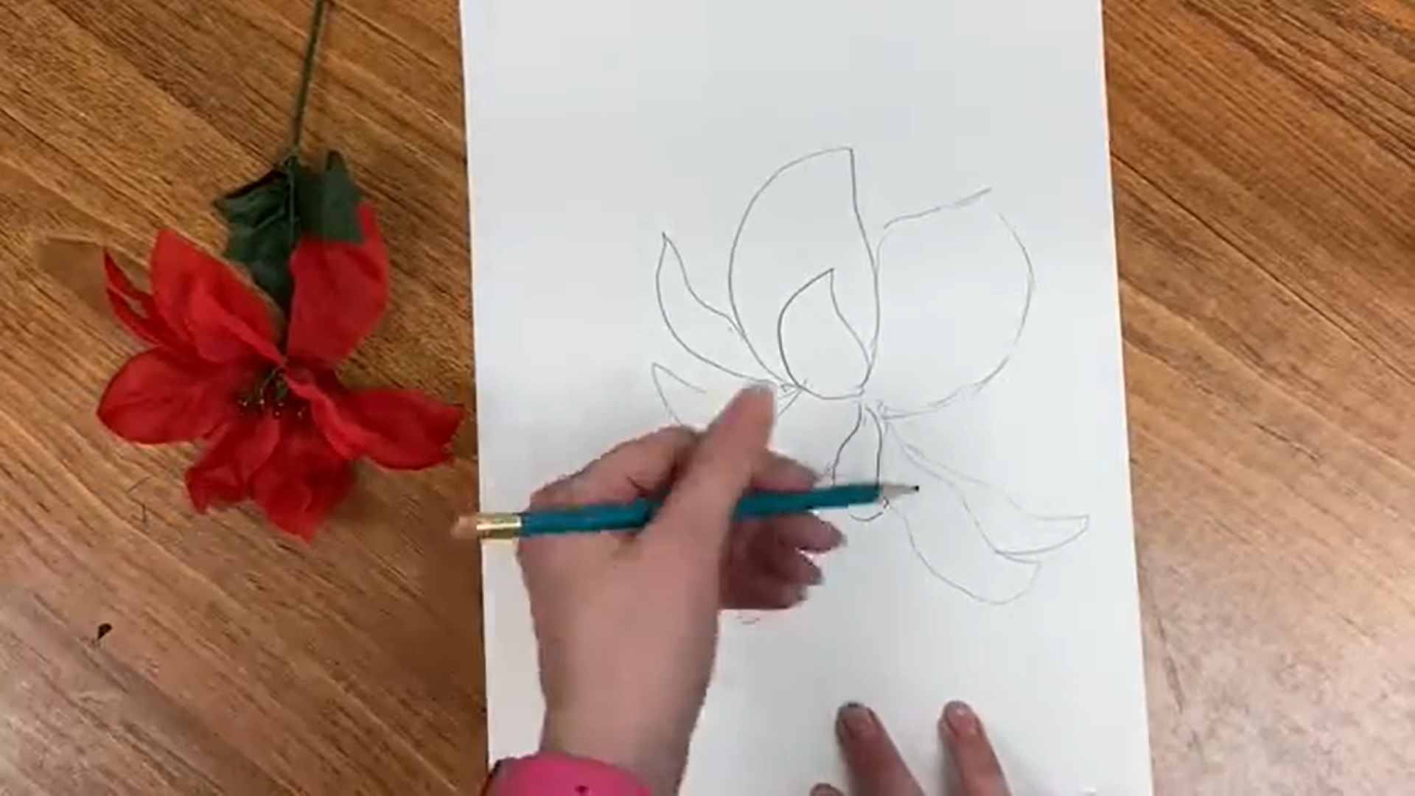
Position flower and paper Draw the shapes you see
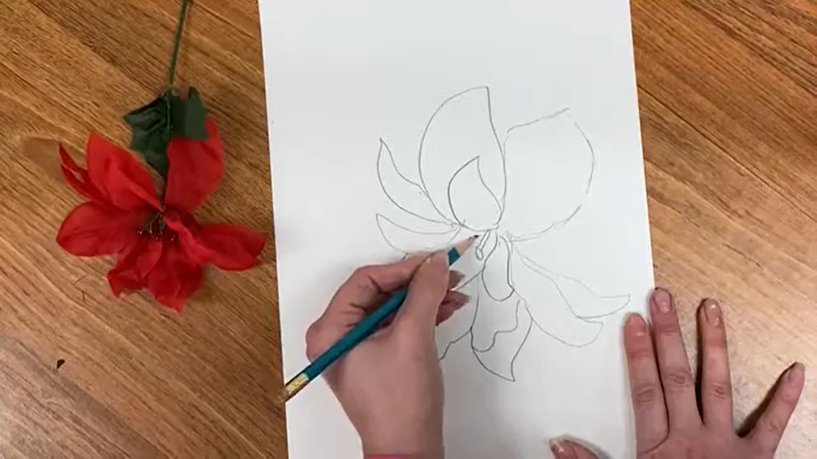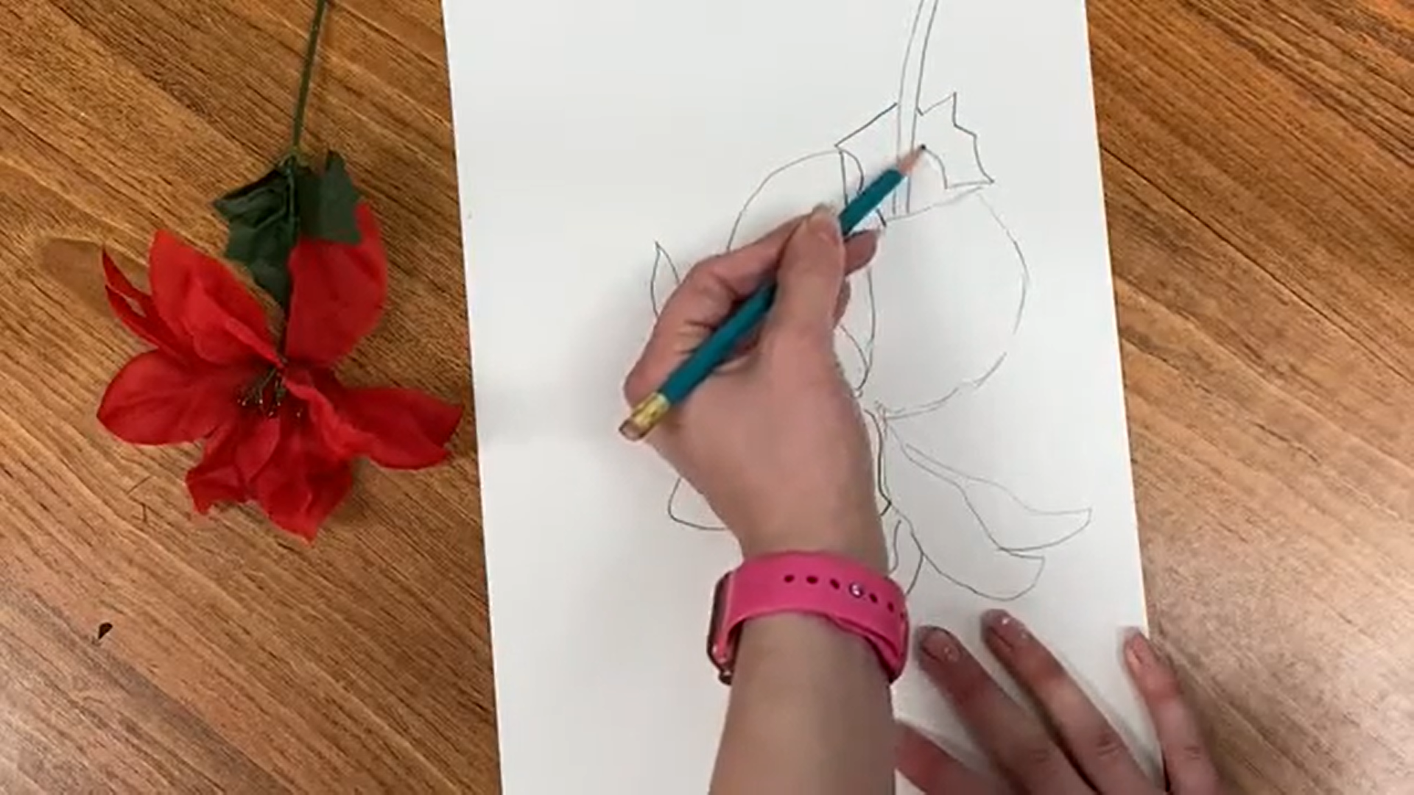
Add detail to the drawing Fill the page

Apply paint with a range of tools
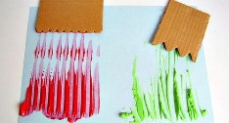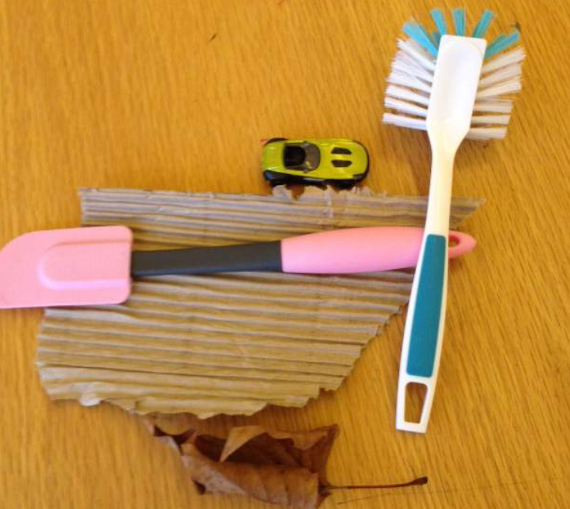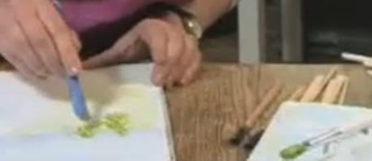

Creating different textures with paint
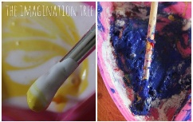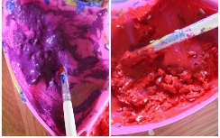

Key Vocabulary
Brushstroke | The marks a painter makes with their brush.
Impasto | Applying thick layers of paint, which leaves bumps on the surface.
Primary Colours | Yellow, red and blue. These colours cannot be mixed from other colours.
Shade | A shade is created through the combining of a colour and black.
Texture | The way something feels.
Tint | A tint is created through the combining of a colour and white.

What will I know by the end of the unit?
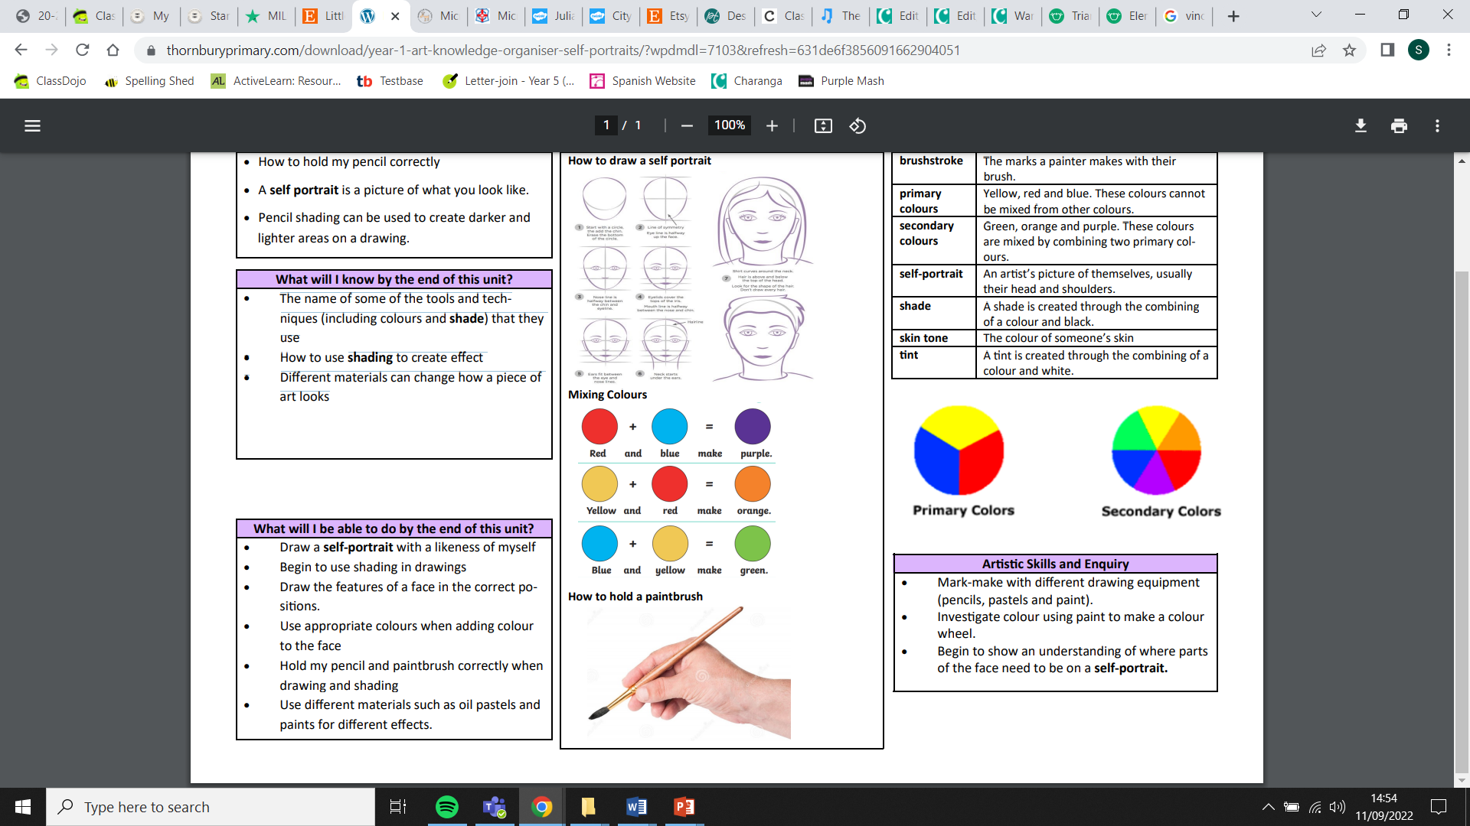
How to hold a paintbrush correctly

How to mix colours to make new colours
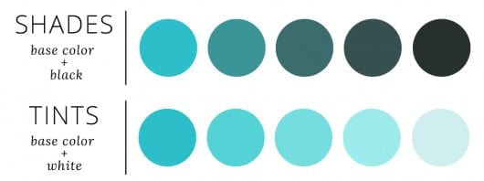

Artist: Vincent Van Gogh (1853 - 1890)
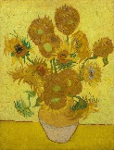
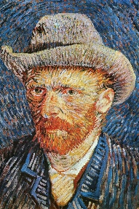
- Vincent Van Gogh was a Dutch painter
- He used a method called impasto
- Van Gogh is one of the most famous and influential figures in Western art history.
- He painted almost 900 paintings in 10 years (over 2,000 pieces of artwork)
- He only sold one painting when he was alive

