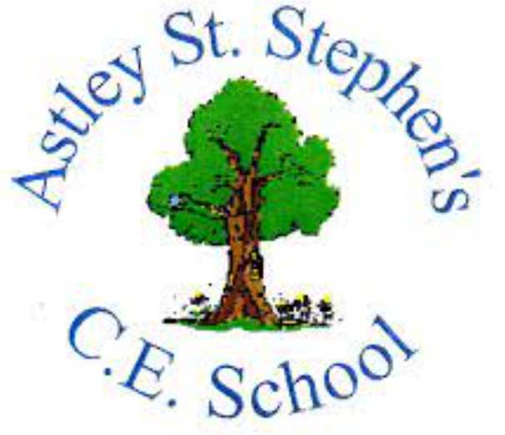 | Art
 | Autumn Term | Year 1 | Area of Study: Printing
What should I already know?
- You can print with fruit/vegetables.

- In printing you can make repeated patterns
Key skills
I can print with objects:
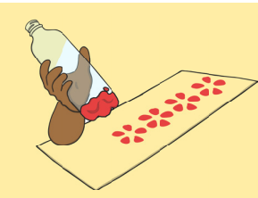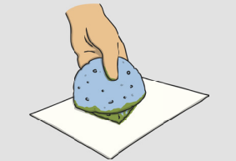
I can print using a potato:
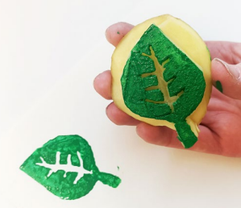
I can print using natural materials:
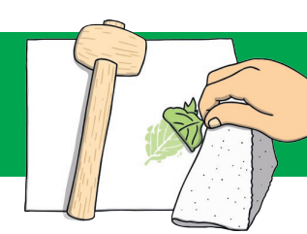
Key Vocabulary
Natural materials | materials that come from plants, animals and rocks
Pattern | a repeated decorative design
Print | copy of an image from one surface to another
Repeated Pattern | where shapes or colours repeat themselves as the pattern keeps going
Stamp | a block that when pressed leaves a mark

What will I know by the end of the unit?
I know shapes and colours can be repeated to make a repeated pattern.

I know Orla Kiely likes making repeated prints:
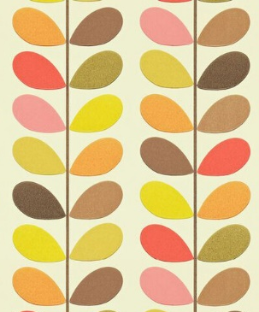
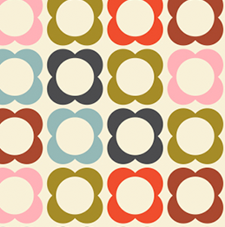

Artist: Orla Kiely (1963 - )
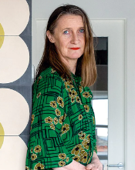
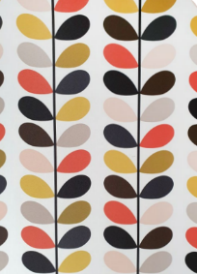
- Orla Kiely was born in Shankill, County Dublin in Ireland.
- From a young age, she was very creative and loved making things.
- She has won many awards.
- Orla uses nature to inspire her designs.
- She has designed textiles, wallpapers, hats, handbags, clothes, furniture, cookware, plant pots and even cars.

