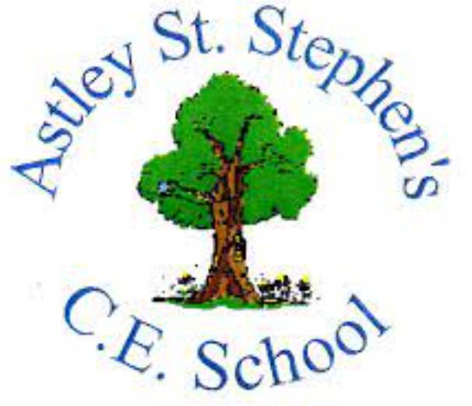 | Art
 | Spring Term | Year 3 | Area of Study: Collage
What should I already know?
- Know that tearing, ripping and cutting different materials has a different effect on the edges.
- That different papers may need different sticking methods.
- Any material can be used in a collage
Key skills
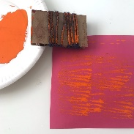
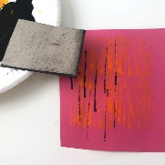
Mark making to make textured, creative paper:
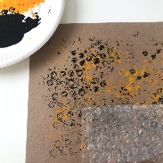
bubble wrap wrapped string card edges

Wax resist to create pattern and texture:
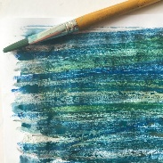
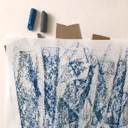
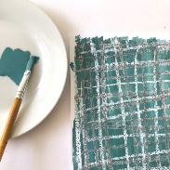

grid method cut-up card speckled pastel
Key Vocabulary
Arrangement | The placement of visual elements in a piece of artwork.
Layering | applying one layer of material over another
Overlapping | the placement of objects over one another in order to create the illusion of depth
Texture | The material can be rough or smooth, plain or patterned
Wax Resist | Strokes are made with wax crayon then overpainted with watercolour. The wash only adheres to the paper where there is no wax. Crayons are used in this technique due to the fact that wax repels water.

What will I know by the end of the unit?
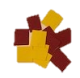
Different Collage Techniques:
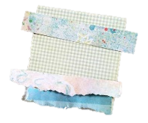
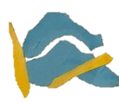

tearing overlapping layering

Collage can be made by:
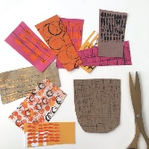

Cutting

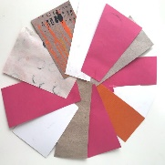

Arranging and Altering

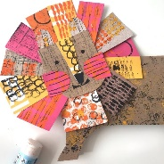
Sticking into position and adding detail

Artist: Clare Youngs (1981 -)
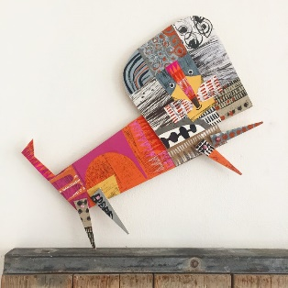
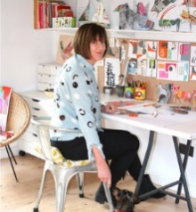
- Clare Youngs is from London, but now loves by the Kent coast
- Youngs’ new projects, thoughts and ideas start as notes and sketches
- Young loves making handmade art and crafting at home
- She is a designer maker, who works with paper and fabric

