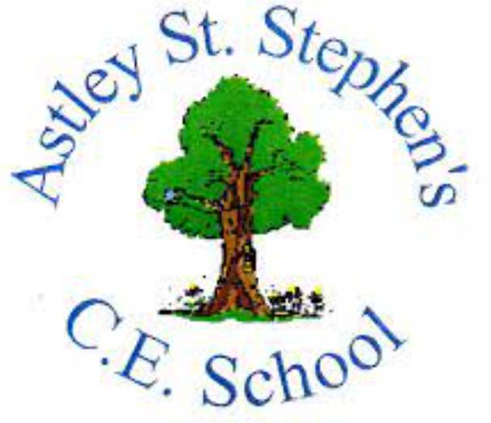 | Art
 | Autumn Term | Year 3 | Area of Study: Painting
What should I already know?
- How to hold and use a paintbrush
- The names of all Primary and Secondary colours
- How to create tints and shade within paint
- How to use shading to create effect
Key skills
Sketch a background/ landscape with simple features such as trees and animals.

Choose the correct tool to create dots.
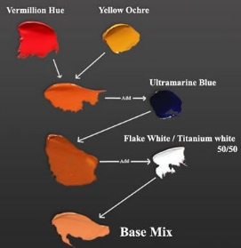
Able to mix skin tone colours.

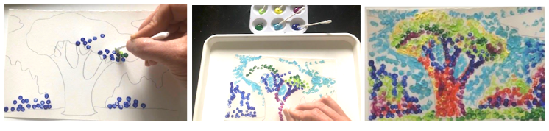
Paint in a pointillism style.

Key Vocabulary
Landscape | Visible features of an area or land.
Pointillism | control over coloured dots, so tone and shading is evident
Sketching | Making a rough drawing of something.
Skin Tone | Human skin color ranges from the darkest brown to the lightest hues
Stippling | A process of painting using small dots
Subject | the “what” in a piece of art: the topic, focus, or image

Artist: Georges Seurat (1859 - 1891)
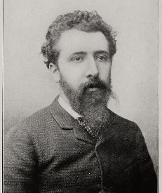
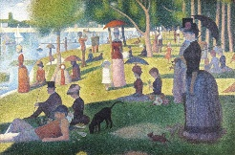
- Georges Seurat was from France.
- Seurat drew pictures/coloured sketches at the riverside to get an idea of how the light would affect his subjects.
- Seurat created a whole new painting technique and he used the science of optics to do this.
What will I know by the end of the unit?
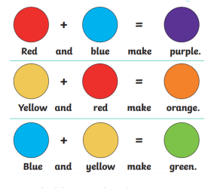
You can mix new colours:

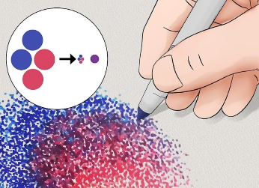

Overlapping colours in Pointillism, creates new colours:

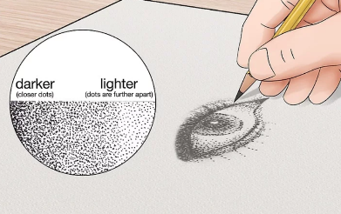

You can create Light and Dark within Pointillism:

