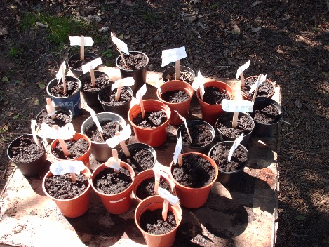
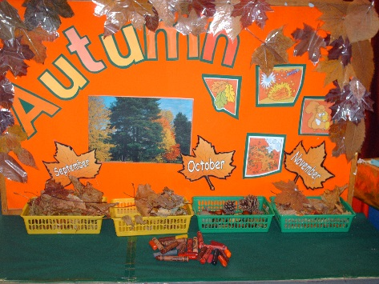
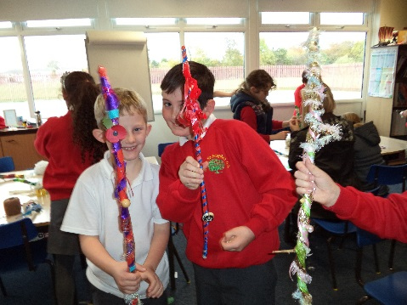
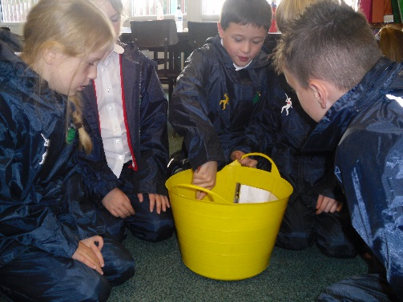
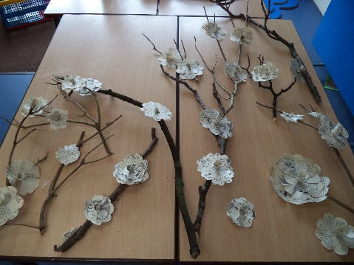
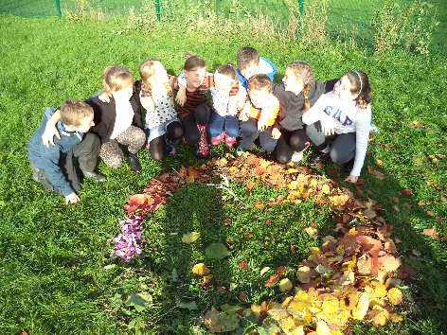
The John Muir Award
and
Outdoor Education

Outdoor Learning – John Muir Award

Introduction for leaders:

The John Muir Award is named after a 19th century naturalist who was the first real advocate of the preservation of wilderness and open spaces. His aim was to bring people’s attention that our open spaces and wild environments will not remain that way unless they are protected. Born in Scotland, he moved to the USA at the age of 11 and grew up to be the founder of the first ever National Park – Yellowstone National Park.

The John Muir Trust is a charity based in Scotland with offices nationwide. They provide an award scheme that helps the participants to appreciate the environment around them and which will help, through education, produce generations of people who will grow up with a desire to protect and nurture their open spaces.

The award is split into three categories: Discovery, Explorer and Conserver Award.

Each award has the same four elements to achieve: Discover a wild place; explore the locality; conserve the environment; share learning with others.

A wild place doesn’t necessarily need to be a huge open area. It could be the school grounds, school garden, a footpath, field, section of woodland, a pond, a river or a meadow.

Wigan has rich wealth of local areas that could be used to help children appreciate and learn more about the importance and value of caring for their natural environment. There are many local parks, woodlands, footpaths, streams, ponds and fields, alongside bigger spaces such as Haigh Hall and the Wigan flashes. The activities planned in this booklet help them to discover – by working in an environment which is not the classroom and offer different experiences and challenges. Explore – using activities to take a closer look at the outdoor environment. Conserve – by understanding that their actions outside have an impact on the natural world and by thinking of ways to improve or protect the environment. Share – by producing art work, poetry, reflections, blogs and take in part in presentations to the school community.

Discovery Award –
In this award children need the opportunity to discover and explore a natural space through a range of activities. They should take responsibility for themselves by following any safety instructions they are given. Children will need an awareness of John Muir and the National Parks before they begin the activities. During their project, they should participate in all four challenge areas with enthusiasm and interest. Opportunity should be given for them to make an improvement to the area they are working within and this should be linked to an understanding of conservation. By the end of the project they should be able to share some of their learning experiences with other pupils or parents. Time period of study should be equivalent to 4 days.

Explorer Award-
This award involves children taking a greater leadership role, they should be better able to make decisions about the safety of themselves and their group, as well as being aware of any impact their activities might have on the environment. Children should engage more thoughtfully with conservation issues and develop their own ideas of how to improve areas, which might include fundraising to protect an area beyond their own immediate environment. Children should gain greater understanding of how their local area has been shaped by events in history, particularly the industrial history of Wigan. In exploring and discovering wild places, they should move beyond the school grounds and into the natural areas within their locality.

Suggested activities to introduce National Parks and John Muir:

- Research John Muir and write his biography.
- Research John Muir and take part in a quiz about his life.
- Use quotes from John Muir as a basis of discussion and create pieces of art work which illustrate the children’s understanding of what he was saying about the natural environment.
- Make a timeline of John Muir’s life.
- Make a leaflet about Yellowstone National Park.
- Mark the National Parks in the UK on a map.
- Create a model of a national park using recyclable materials.
- Visit a national park.
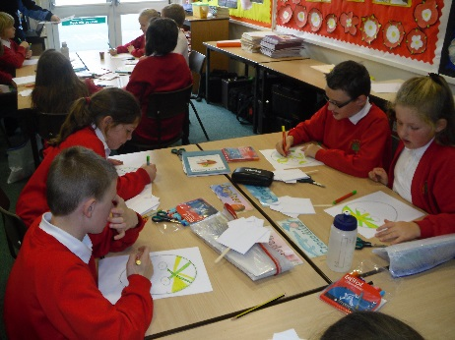
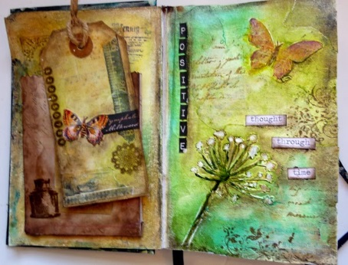
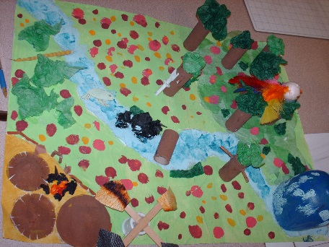
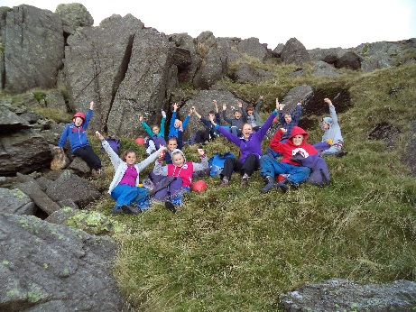

Theme: Fruits and seeds

Objectives | Values |  | Links |  | Resources
- To know how plants reproduce and grow, including the function of different parts  - To understand that plants come from seeds and to write sowing instructions.  - To plan and carry out a fair test investigation.  - To use grown and picked ingredients in a recipe. | Thankfulness – How interdependent are plants, animals and humans?  Do we appreciate the natural resources upon which we depend?  Plant life cycles/food chains  What if seeds just fell to the ground? |  | Science – plants, life cycles, seed dispersal  Science – investigations  Maths – measuring, graphs, scale drawing  DT – model making, cooking, gardening  Geography - mapping |  | Books or sheets about plant parts.  Wild flowers  Natural materials  Art materials – papers, glue, cellotape, pipe cleaners, straws  Tins and packets  Seeds  Papers  Metre sticks and rulers  Blu tac  Glue guns/PVA glue  Ingredients  A selection of seeds (or pictures)
Suggested teaching activities
Provide pupils with a selection of information about plant parts and their functions. Ask pupils to make a labelled drawing of a flower and its parts and their function using flowers from the local environment. Let pupils find a wild flower and ask them to dissect the flower finding and naming the different parts. Have children design and make a model flower for a specific insect to pollinate following given clues. Working in teams and using natural materials pupils make a picture of the life cycle of a flowering plant and add labels.

Explore the seed dispersal aspect of the life cycle of a plant. Look at the different ways seeds can be dispersed and sort a selection of seeds into groups (use a seed hunt to find different types of seeds). Investigate seeds which use wind dispersal by making model helicopters and flying them in the environment – what impact does the wind have? Have children select a factor they could change about the seeds (materials, weight of seed, size, length of arms) and plan and carry out a fair test. Make a graph of the results. Share findings as a whole group and then have pupils try to build the most effective seed. Have a challenge to see whose seed travels the furthest.

Help children to understand that fruits and vegetables are grown rather than coming from a supermarket and that many products we buy are made from these. Collect together a selection of tins and packets which are fruit/vegetable based eg. Tomato sauce bottle, sweetcorn tin, pea soup, strawberry jelly pot etc. Children pot seeds for the fruit or vegetable in the packaging and watch the progress of growth.

Go blackberry picking and then use the blackberries in a recipe (in combination with apples if you have trees or access to an orchard) – spiced apple drink, fruit crumble, blackberry fairy cakes. Discuss the animals which might spread the blackberry seeds in your environment. Make toffee apples. Enjoy a picnic in the outdoors to enjoy the results of cooking.

Have a scavenger hunt to find a range of Autumn objects.

Plant strawberries, raspberries or other soft fruit. Prepare the ground first by weeding. Make a map or scale diagram of where different fruits will be planted. Pupils make their own seed packets and add clear instructions how to sow them for the back of the packet.

Create conker monsters using natural materials and glue or blu tac to join up the parts.

John Muir links
Pupils explore the fruits and seeds that are found in the local environment. Through investigations they discover how plants reproduce and the importance of seeds. Using fair testing they carry out an investigation into wind dispersal and share their findings in a graph so that everyone can use the data to design a seed. Pupils conserve an area of the school grounds by creating a place to grow fruits.
Lower stage |  | Middle stage |  | Upper stage
Make simple diagrams of plant parts.  Simple life cycles.  Seed hunts  Shared fair test  Blackberry picking and following a recipe |  | Label plant parts and functions  Dissect and compare wild flowers.  Investigate plant life cycles.  Seed sorting  Guided fair test  Pick fruit and create recipes  Grow fruit  Model monsters |  | Design a flower for a set criteria based on dissection of wild flowers  Compare different lifecycles.  Classification of seeds  Design question and fair test  Find own recipes for picked fruit
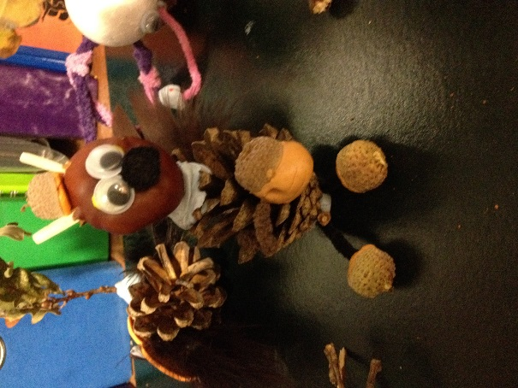
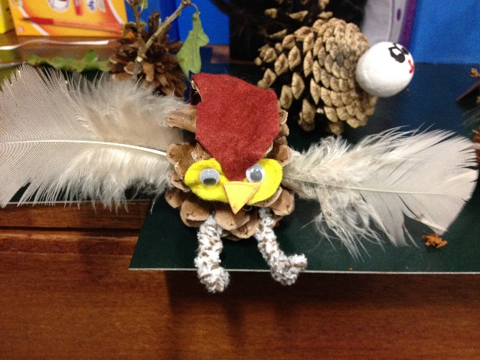
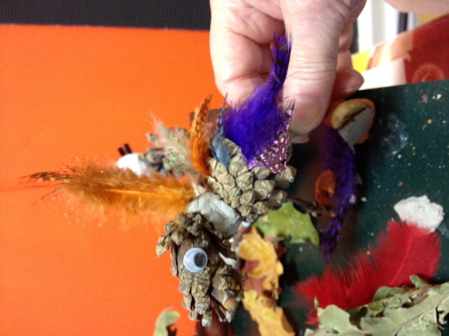

Theme: Sensational!

Objectives | Values |  | Links |  | Resources
- To explore the local environment using senses.  - To use scale plants to design and create a garden.  - To investigate the colour wheel  - To make links between colour and mood  - To understand propagation as a method of reproducing plants  - To compose a piece of music using natural materials | Reverence – How do we should respect for the world around us?  Do we have a sense of awe and wonder at the world we interact with?  Labyrinth of senses  What if we could only see the world in black and white? |  | English – poetry  Maths – scale drawings, measuring  DT – recipes, gardening  Art - Colour  Music – composition  Science – plant life cycles  History – uses of herbs  RE – reflection/spiritual journeys |  | Paper strips and pencils  Soft fruits and smoothie ingredients  Seeds  Soil  Rulers  Colour wheels  Green shade cards  Clip of stomp  Recycled materials for instruments  Sound recording equipment  Mature herb plants  Scissors  Small plant pots  Soil and sand  Lollipop sticks  Magazines or scrap coloured paper  Chalk
Suggested teaching activities

Give children strips of paper and pencils. Travel around different parts of the school grounds and focus on senses. Stop in one place and listen very carefully record and describe sounds. Next do the same with sight, smell, touch etc. Gather together at the end with the strips and share some of the ideas. How can they be improved – by adding description? More powerful words? When the phrases are improved put them in order to create a poem – individually, in pairs or groups.

Select an area in the school grounds were fruit, vegetables and herbs can be grown. Measure the area and make a scale drawing of the garden. Use seed packets to see how much space different fruits and vegetables need and draw a scale plan of the garden. Plant the seeds. Design and create a devise to water the garden. Care for the plants and when ready harvest them and create a special lunch to have as a picnic together.

Use soft fruits such as blackberries, strawberries, raspberries to create smoothies to drink in the outdoors.

Introduce the idea of colour in a garden. Ask where colour comes from in a garden – flowers, foliage, stems, branches, soil, walls, paths buildings. Is all foliage green? Show examples of different coloured foliage. Use green shade cards (cut a hole in the card so children can match the leaves closely). Choose a colour and go out in to the garden to find that colour. Introduce the idea of a colour wheel. Provide colour wheels for the children to look at, explain how a colour wheel is structured:
▪ Colours of the rainbow formed into a circle.
▪ Each colour is pure
▪ There is no black or white
▪ 3 primary colours – Red, Yellow & Blue
▪ 3 secondary colours – Orange, Green & purple (violet) – contain equal proportions of two primary colours.
▪ 6 intermediate colours contain varying proportions of primary colours
•Explain how a colour wheel works:
▪ Adjacent colours create a harmonious effect
▪ Opposite colours complement

Go outside and use colour wheels or colour charts to match colours. Use sticky strips to collect fallen plant parts which match the colours on the colour wheel as closely as possible. Create a colour wheel using natural materials.

Give children a long piece of ribbon or sticky tape and send them out and about to collect twigs, leaves, petals, flowers, shells, pebbles, feathers etc. Create a record sheet or table to record information which uses the senses such as size, colour, texture. Lay out the earth lines to look at the different things collected. These could be turned into fence weavings, be hung from trees or used to create art in the style of Andy Goldsworthy. Use the earth lines as the basis of a poem or piece of creative writing.

Take a tour of an outdoor area and explore how many different sounds can be made – running sticks along railings, creating a leaf whistle, shaking pebbles. Working in small groups children choose different objects to use as instruments and make a composition – this could be to tell a story or a rhythmic piece. Perform and record your music. STOMP could be used as inspiration for a piece using dance and rhythm.

Teach children about propagation by taking cuttings from established plants and encouraging it to grow roots a new plant can be formed. Look at some endangered plants that have been saved by cloning. Identify and take cuttings from some herbs – e.g. mint, lavender, sage, thyme, Encourage touch, smell and where appropriate taste to explore the plants. Fill plant pots with sandy soil. Take a cutting from just below a leaf joint or above a bud. Dip the end of the cutting in rooting hormone and then using a lollipop stick make a hole in the compost and plant the cutting. Water the plants and then using lollipop sticks cover with a plastic bag and secure with an elastic band. Once plants have rooted they can be planted out. Look at the use of herbs in the Middle Ages and Victorian times. Why were they important? How were they used? Once the herbs have grown use them to make something – mint lemonade, sage/rosemary cheese scones, lavender scented bags etc.

Audit your school grounds. Talk with the children about the mood of different colours. Outside in the school grounds look at the colours present and make a mood board using old magazines or scrap paper. Next have the children make a mood board of how they would like the school to look. Plan and make some improvements to the environment. This could also be done with textures.

Create a labyrinth which uses all of the senses. Research some labyrinths with the children – Chartres in Paris has a famous one. These are a spiritual journey and have been in existence for centuries. These could be created as a whole class or in teams. Decide on a design for the labyrinth and use stones, chalk, twigs or other method to create the shape. At intervals pupils should create a reflection activity which uses the senses. They could place a thoughtful question which others could write an answer to; give an activity such as tasting or touching different textures; a poem could be created by building up sections etc.
John Muir links
Pupils explore the local environment using their senses and making descriptions through poetry. They discover how herbs can be propagated and how they were used in history, including how this method has been used to conserve endangered plants. Through the work of Andy Goldsworthy and by learning about the colour wheel they explore the environment in colour and share their learning through land art and musical composition. Working in teams they design a labyrinth and share their experience with other children. They conserve the school grounds by looking at ways they can improve the mood of the local area through colour and/or texture.

Lower stage |  | Middle stage |  | Upper stage
Use senses to explore the environment.  Use grown fruit and recipes to make and taste smoothies.  Make things using herbs for taste and smell.  Explore colour in the local environment.  Use natural materials to create sounds. |  | Write senses poems and make a class labyrinth.  Grow own soft fruit and make smoothies.  Propagate herbs.  Create a colour wheel and understand its use for artists.  Compose a piece of music using natural materials. |  | Create labyrinth journeys for other children to explore their senses.  Use maths to create a develop a soft fruit growing area.  Know about the history of herbs and how cloning can be used to safe rare plant species.  Explore the work of Andy Goldsworthy.  Create a stomp style dance and composition
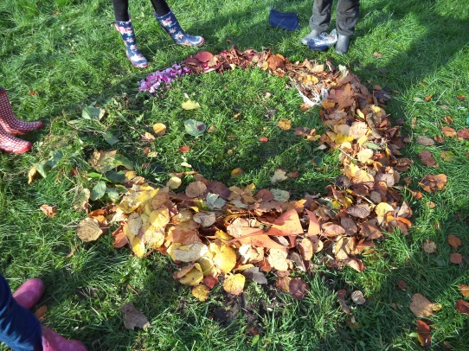
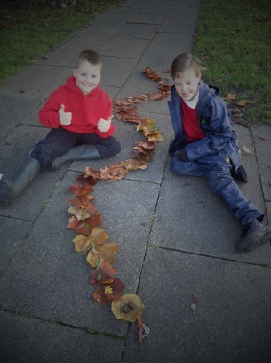
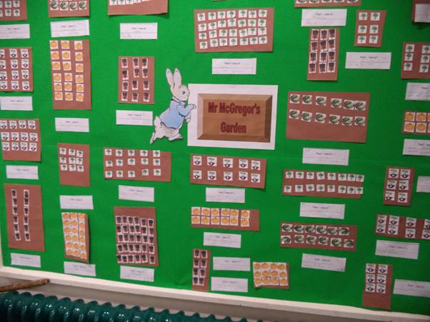

Theme: Mini-beasts and monsters

Objectives | Values |  | Links |  | Resources
- To investigate the different environments which attract mini-beasts  - To sort and classify living things  - To read co-ordinates  - To make careful observations and make models  - To understand how animals adapt to different environments | Compassion – how do our decisions impact on creatures such as the bumblebee?  Creating a bee friendly area  What if there were no more bees in the world? |  | Science – keys, composting, adaptation  DT – model making, gardening, recipes  PE – team games  Maths - co-ordinates  Art – 3D models, sketching  English – writing  Maths – symmetry  Geography - mapping |  | Seeds  Insect keys  Magnifying glasses  Glue guns  Compost ingredients  Leaves  Books or sheets on worms  Soil and tank for wormery  Brown and green wools  Sticky tape or Velcro  Green paper  Equipment for swamp challenge  Recipe ingredients  Bee friendly seeds  Paints  Varnish  Sticks  String  Card  Butterfly ID cards  Coloured pencils
Suggested teaching activities

Take children outside to discover which minibeasts live in different habitats. Discuss the features of each of these and their adaptations to their habitats and feeding patterns. Use simple keys to identify creatures. Create a simple classification key. Make maps of the locations in which different mini-beats were found. Collect a selection of seed cases, seeds and plant parts to use for making seed bugs. Discuss the features of the minibeast observed outside. Discuss body parts, wing and leg structures, antennae. Show the children an example of a ready made bug and discuss what they will need to make their own bug. Decide if it needs to be realistic eg an insect with all the features or an imaginary creature.

Research the importance of mini-beasts to the environment. Explore ways that more mini-beasts can be attracted to the environment. For example, build a log pile using leaves and dead branches; make an insect box from twigs tied together with string; fill old plant pots with leaf debris; create a rockery.

Create compost and discover which ingredients speed it up. Make a leaf bin to hold the compost. Once it is ready use the compost on your growing area. Research the worm and find out how this creatures helps the garden (you could make a wormery).

Discuss the meaning of adapted (suited) and environment (habitat/climate).Tell children about how moths changed their colours to fit in with dirty tree bark during the industrial revolution/Victorian era. Focus on the camel. Working in small groups challenge children to think of as many ways as possible that a camel is adapted to the desert. Feedback and discuss whole class. Make sure that you have an equal number of each colour of wool caterpillars. Use both bright colours and some greens and browns. Prepare a board with strips of double sided sticky tape or Velcro (hooked side). Randomly distribute the caterpillars over a large designated grassy area (about 12m x 12m). Tell the children they are hungry birds looking for food. The children look for the ‘caterpillars,’ collecting one at a time and sticking them on the board. Make sure they are stuck in order as they are found. The brighter colours will usually be collected first. Either continue until most of the wool is collected or allow a set time.

Make lily pads from green paper (large) how frogs (children) can you fit on a lily pad? Lay out a swamp area and provide teams with a set of equipment – can they cross the swamp without getting their feet wet? Challenge: blind fold one person, link the arms of two people, have one person hop etc.

Play battleships, but replace the traditional ships with different mini-beasts.

Collect rocks and pebbles, along with other natural materials such as leaves and twigs. Use photographs or research books to explore different mini-beasts and paint up the pebble to look like a mini-beast. Varnish the models. As a class or group design an outdoor habitat for the pebbles creatures to live.

Choose three areas to explore and count the number of bees you can see. Make a graph or chart and reach a scientific conclusion based on the environment and what it provides for the bees. Identify a suitable bee friendly area and using the information from the graphs plan and create a bee friendly zone. Learn about the importance of bees through www.bumblebeeconservation.org.uk Use local honey to cook, for example honey cakes.

Imagine being a small creature such as a caterpillar or spider. Explore the environment through the creatures eyes – what would things look like? What might you hear that humans don’t? What smells might attract you? Create a poem or piece of creative writing following the journey through a mini-beast’s eyes.

Look at different butterflies using an Identification key. Make a sorting diagram or branching tree to identify the different species. Find out which butterflies in the UK are at risk. Create a butterfly mobile, looking carefully at the colours, patterns and shapes of different butterflies. Investigate symmetry in butterfly patterns. Go on a butterfly hunt.
John Muir links
Pupils explore and make careful observations of the features of different mini-beasts and classify them. They discover where mini-beasts like to live and the needs that these habitats fulfil. They share their learning through art, writing and investigation reports. Pupils learn about adaptation and use their knowledge to conserve an area by creating a bee friendly zone or an area to attract mini-beasts.
Lower stage |  | Middle stage |  | Upper stage
Locate and observe different mini-beasts.  Make models using observation.  Investigate caterpillar adaptation. |  | Group and classify mini-beasts.  Map mini-beast habitats.  Make careful observations of features and use in model making.  Know some ways animals adapt to environments.  Learn about bee conservation. |  | Create classification keys and branching diagrams.  Identify habitats for mini-beasts and draw conclusions which help to build friendly areas.  Know about adaptation and Darwin’s finches.

Theme: Trees and leaves

Objectives | Values |  | Links |  | Resources
- To explore the different species of trees found in the environment.  - To sort and classify living things.  - To apply measuring skills  - To follow maps and directions  - To make careful observations to record in poetry and art  - To use the imagination to explore the environment | Creation – How do we use the earth’s resources for our needs while still being good stewards?  How can we use our own creativity to explore the woodlands?  Tree planting |  | DT - shelters  Maths – measures, graphs, symmetry  Geography – directions, maps  PE – team challenges, orienteering, keeping fit  Art – sketching  English – speaking and listening, poetry, descriptive writing  Science - classification |  | Measuring equipment  Blindfolds  Rope  Orienteering markers  Map of area with trees  String  Squared paper  Mirrors  Sketch pencils  Pastels or watercolour paints  Leaf shapes
Suggested teaching activities

Use materials in the environment (woodland) to construct a shelter for a team, think about wind direction, strength, safety – if woodlands are not available a smaller scale version can be completed with just a few trees eg. Tree houses for toys, fairy shelters.

Investigate the height of a tree using the RHS session, select appropriate measurements for the age/ability of the class and discuss how to measure distances.

Using woodlands or the school grounds, pupils work in pairs. A is blindfolded, B chooses a tree and gives careful directions to get their partner to the chosen tree. Change roles. Discuss which skills were needed? Reflect on how it might be possible to complete the task more speedily by using different skills and giving better instructions.

Challenge to tie a knot around the tree/post, while all members of the group are holding the rope. Imagine the rope is ‘covered in glue’! Place an even number of team members on the end/tail of each rope. Once the rope is picked up you must remain in contact with it. If any member of the group lets go, the group must start again or use another forfeit. The task is completed when a knot is tied that will not come undone when pulled.

Make a map of an area which includes trees, record numbers on the map to show where orienteering controls will be placed. Bought controls can be used or you could place codes to be solved, pictures of woodland animals/names of trees to be matched to numbers. Put out 20 controls. Each pair needs a control card with 20 numbered boxes. At the control, punch your card (or draw the picture/solve the code) in the correct box, repeat until you have visited all 20. You may only punch one box at a time. Give pairs different starting numbers Time pupils to see who can complete the course in the shortest time.

Divide the class into teams and ask them to predict whether all leaves are the same shape and size. They could discuss this in pairs. Ask each team to collect a number of leaves. Once people have picked a handful, challenge them to find two identical leaves. Ask for feedback as to what methods they used to identify the differences between leaves and check if they have found two the same. Leave may be similar but each one is unique. Each team should be asked to make estimates and then make measurements.
If you want to measure;
• The perimeter of a leaf, you will need string and a ruler. Lay the string around the edge of the leaf and then measure how long the string is.
• The area of a leaf, you will need squared paper. Draw around the leaf and count the number of squares inside the shape.
• Length, width, dimensions of a leaf. You will need a ruler and notepaper. Make sure this group always measure the same dimension.
Make a graph to show types or sizes of leaves. Draw around a leaf, cut out the shape and fold it in half. If the two halves mirror each other then you have found the only symmetrical leaf in the world.

Look careful at the shape of different winter trees and use these to identify the species. Make careful pencil sketches of the trees, look at branch shapes, twigs, trunk etc. Complete the picture by adding a winter sky or sunset using pastels or water colours.

Interview a tree. Imagine what a tree will have seen in its long life – how the world will have changed. Work in pairs, one stands behind the tree, the other interviews. Use the imagination to come up with answers.
Find a tree with a natural entrance or window. Sit together around the tree and begin to build a story together. Where might this be secret entrance to? Describe the world inside. What is hiding in there? Is a gateway to another time or place?

Collect together different natural bits and pieces. Look for inspiration for a tree collage. Make a tree picture on the ground using only natural materials.

Go on a leaf hunt to collect as many different leaves from different species of trees as you can. Use classification guides to name the different leaves. Create your own branching diagrams or sorting keys by asking questions to separate leaves.

Run a tree work out. Create a trail of tree keep fit activities with instruction cards at each point. This can be run as a competition eg. Speed of completing the course, recording results for each activity and allocating points.

Discuss how images are used to portray a moment in time. Choose an interesting tree and go and look together. Think about what can be seen, smelt, the texture of the tree and ask children to come up with lists of describing words. Look at how to extend an idea – the tree, the gnarled tree, the gnarled giant tree, the gnarled giant tree stands in the silence of the garden.
Explain that Haikus build up an image. Eg
The gnarled, giant tree,
Silent in the woods
Cradles a ladybird asleep

The ancient, wise tree
In the quiet corner
Keeps whispered secrets

Work in pairs or small groups to create a haiku and sit round the tree to share them.
Or use the senses to create a poem, give out leaf shapes and fit the poem into the shape. Back in class create a display of the leaf poems.

Take part in a tree planting project and find out about the importance of trees to the environment and the impact of delining woodlands.
John Muir links
Children explore a local woodland environment using poetry, art, maths and science. They discover the different species of trees and the different types of leaves to be found in the environment which they can classify. They share their experience through observational drawings and collages, poetry and imaginative writing leading to a display. Children find out about the importance of woodlands and the work of the woodlands trust, they conserve an area by taking part in a tree planting activity.
Lower stage |  | Middle stage |  | Upper stage
Carry out leaf hunts and make comparisons and graphs to show findings.  Build a shelter for a toy.  Take part in team activities.  Use the senses to write poems. |  | Identify, classify and measure different leaves.  Work in a team to build a shelter.  Follow a picture or code orienteering course.  Create a class tree of shape poems.  Make a tree collage. |  | Create classification keys and measure the height of trees.  Follow a map based orienteering course with stations.  Write haikus  Sketch a winter tree
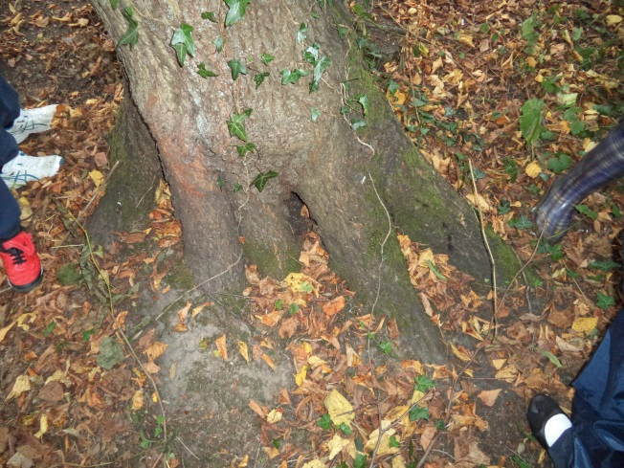
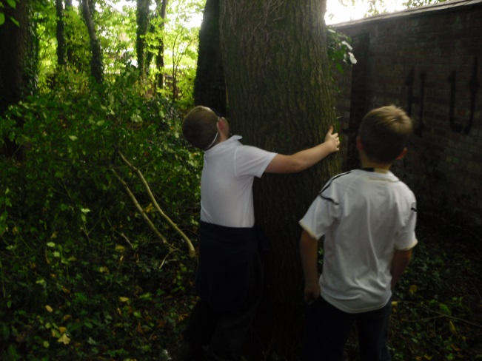
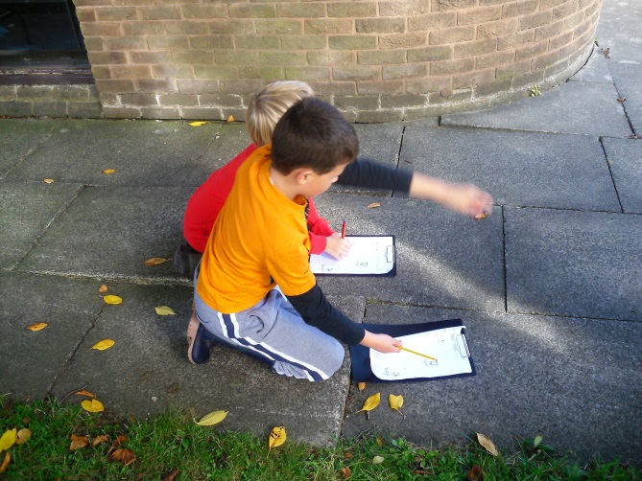

Theme: The stick project

Objectives | Values |  | Links |  | Resources
- To identify and classify sticks from different trees  - To make wind chimes as an inspiration for descriptions  - To use twigs as a material for land art  - To use signs and symbols to make a map.  - To construct a story using a stick as a planning tool.  - To know the parts of a skeleton and their function | Endurance – What difficulties might people face on a journey? How do we meet challenges with courage and tenacity?  Journey sticks |  | Science – classification  Music – pitch, instruments  English – descriptions, story structure  DT - mobiles  Art – land art, weaving  Geography – signs and symbols  Science - skeletons |  | Stick id sheets  String or thread  Loads of sticks  Wool  Ribbon  String  Thread  Pieces of paper
Suggested teaching activities
Go out on a stick hunt to find sticks from different trees, identify the different sticks and explore the features that help to classify them.

Ancient Celtic tribes made wind chimes to scare their enemies into believing the woods were haunted by ghosts. Look at some wind chime designs and find out more about their history. Look at how the pitch of an instrument changes according to size. Build a wind chime using sticks of different sizes and see how the sounds change in the breeze. Listen to the wind chimes and create ghostly Celtic descriptions of the woodlands.

Look at the work of different land artists who use sticks as their medium. Work in small groups to create pieces of art work, such as real woodland animal sculptures, dragons or stick piles inspired by the artists.

Working in small groups create a trail by designing different symbols to give directions. Choose an end point or have some treasure and set up the stick trail. Swap trails with another group and see who can reach the treasure or end point first.

Use a stick to make a leaf mobile. Within the mobile add in poetry or describing words phrases or make 3D flowers using paper with descriptions and poems written on.

Stick weaving – find a forked stick on the floor, use wool or string wound from one side to the other to create a base for weaving – use natural found materials or different wools and ribbons.

In many countries people have developed the idea of a journey stick which tells the story of their journey, their feelings and experiences. Whittle a piece of wood and then travel on a journey. Use different coloured wool wound round the stick and attach found items to tell the story of the journey. Hang the sticks from a winter tree for decoration.

The woods can inspire lots of stories. To help children structure stories have them find a good long stick and give them small pieces of paper and some thread. Help children to build up a story – begin with a character (doodle them), why are they in the woods? Move through the forest as if you are that character, make notes as you see the woods through their eyes. Something exciting and problematic happens what is it? How might it get worse? What could they do? How can they resolve the problem? What happens at the end? Children might collect different items to add to the stick to remind them of the story. Use the story stick to write a twisting, turning story. This could also be used with a familiar woodland story.

Look together at the parts of a skeleton. Go out into the environment and find different objects to represent different parts of the skeleton and add labels.
John Muir links
During this project children will explore their local environment by travelling using a journey stick to record their experiences and feelings. They will discover the different types of sticks in the area and use these to create art work based on land artists. They will explore how the pitch of an instrument changes through investigation and will discover how the Ancient Celts used wind chimes. As a class they will share and write stories using journey sticks to plan the sequence of events. By creating journey sticks to decorate a tree or area they will improve and conserve an area of the school.
Lower stage |  | Middle stage |  | Upper stage
Hunt for and compare different twigs.  Make wind chimes.  Use twigs in land art.  Follow twig symbols.  Use a journey stick to record thoughts and feelings. |  | Identify the trees different twigs come from.  Use a pitch investigation to create a wind chime.  Explore the work of different land artists using sticks.  Create a twig symbol journey.  Improve a winter area using journey sticks and weavings. |  | Classify different twigs and the trees they come from.  Know the Celtic history of wind chimes and link to creative writing.  Create a map for a stick journey.  Use journey sticks to create a written story.
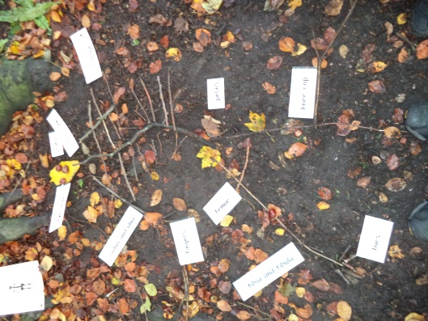
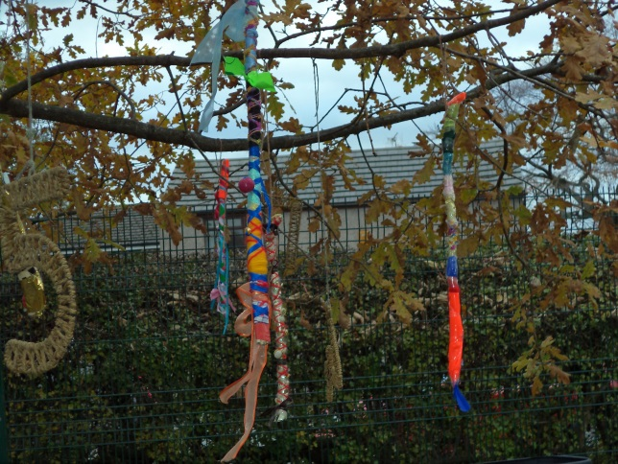
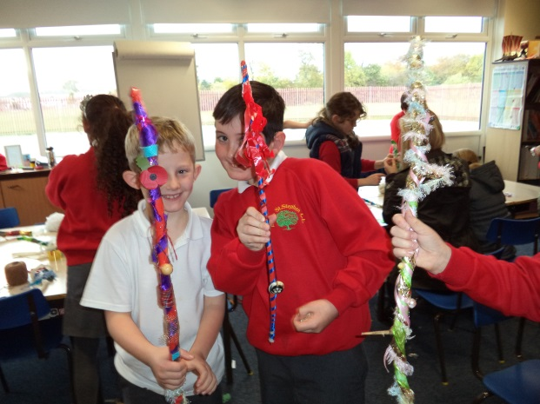

Theme: Birdwatch

Objectives | Values |  | Links |  | Resources
- To identify and classify garden birds  - To carry out a bird survey of the local area  - To research rare and endangered birds.  - To raise funds to support the RSPB.  - To investigate migration.  - To investigate flight and forces. | Service – How can we give in such a way that we make a difference in the world? How do we feel when we serve our world or community and make changes?  Fundraising for RSPB |  | Science – forces, migration, classification  Maths – angles  DT- Shelter building, wood model making, recipes  Art – sketching  English – reports  PE – orienteering |  | Sticks  Balloons  Different elastics  Rulers  Angle measurers  Bird ID sheet  Bird magazines  RSPB Wildlife in Action Awards Pack  Canvas  Paints  Ingredients for bird food  Wood  Saws  Glue guns  Fruit juice/milk cartons  Range of papers  String  Birdlife magazines and books on birds
Suggested teaching activities

Use the bird ID sheet to explore and compare different garden birds by their features and colours. Create classification keys to identify the different birds. Make careful sketches of birds seen commonly in the school grounds or local area. Look carefully at features, colours and patterns.

Plan a bird watch and take part in the RSPB garden bird watch survey www.rspb.org.uk/birdwatch Make a bird feeder using old cartons and fill with a recipe for bird seed. Make fat balls or other bird foods. Working in groups create a camouflaged shelter using canvas and paint in colours and patterns to match the environment where the bird watch will take place – make slits to view through. Set up an area for bird watching with shelters and bird food. Record the different species seen using binoculars and recording sheets. Use the information collected by groups to make a collated graph (this could be a large scale outdoor version) send the results to the Big Garden Bird watch and make comparisons with national findings. Build nest boxes and regularly refill the feeders in a quiet an area to attract garden birds.

Use books and the Birdlife magazine to research rare and at risk British birds. Make a display of reports, sketches and photographs to show to the school community. Plan a fundraiser for the RSPB to help their conservation work.

Make bird kites using the features of common garden birds and fly these in the school grounds.

Show the Animated Tale Swallow (can be found on the Hamilton Trust website). Discuss whether this is a made up story or whether any parts of it are true… Take feedback. Write ‘migration’ on f/c. Some chn may know what this means. Some birds only come to Britain for the summer months, and then they fly back to other countries or even another continent for the autumn and winter and some of spring. Return to Swallow’s journey and click through the story to look at the 2nd map and then the rest of the maps through the story. Explain that all swallows do fly from South Africa to England, Wales or Scotland. The part where he ‘makes a mistake’ and flies the wrong way south to Antarctica is NOT true. Show chn on a globe and a map of the world how swallows fly from Africa to Britain. Give out copies of a map of the world and ask chn to draw the line to represent swallow’s journey just like on the Animated Tale. Talk about where he stops (jungle, Sahara desert, mountains in Switzerland) and point out these areas on the globe. Make sure chn’s lines go through these places. Remind chn that in the autumn these swallows fly all the way back to South Africa – they are only in Britain to lay their eggs/raise their babies. Swallows eat flies – plenty of these in summer here!The swallow starts in South Africa and flies all the way up Africa, across the Mediterranean Sea and up across Europe to the UK. Point out this route on the globe and the world map. Show three bird pictures (session resources). Point at the first picture. Do chn recognise this bird – whisper its name to a partner (Swallow). The swallow is a summer migrant – write this on f/c. this means it spends summer here and then migrates somewhere else (Africa) for the rest of the year. Point at the second picture and ask chn to whisper this bird’s name to a partner (Robin). Explain to chn that our British robins are joined in winter by robins from Scandinavia and northern Europe – these come to the UK because it is warmer here and there is more food for them. These visiting robins are called winter migrants (write this on f/c) because they are only here for the winter. Point at the third bird. This is a Redwing – it is a bit like a song thrush but it is much rarer – so we are not likely to spot one! It also spends winter here, and then returns to Scandinavia where it spends the rest of the year. It is a winter migrant. With chn, look at the globe and point out where the visiting robins and the Redwings fly from (Denmark, Norway, Sweden…) to here. It is nowhere near as far as the swallow’s fly.

Look at the angry birds’ game together or talk about it. Go outside to do a live version of the challenge. Create a catapult with which to propel the birds. Use a large, sturdy branch with a V or U shape towards the top or construct something similar. You could test out a few different elastics to find the one that works best. Make your ‘birds’ by filling each balloon with the same
amount of water. Start with a few trial runs. Getting the angle of releases vital in order to aim the birds – too low an angle and the birds do not fly very far, too high an angle and they will travel up into the air but then drop straight down. The most effective angle for long shots is 45 degrees. Measure how far each bird has travelled before landing. Each should end up in roughly the same place. Ask the children to guess where the birds will land if you:• alter the angle of release • alter how far back you pull the catapult • alter the size of the birds.

Set up an investigation using the school science investigation sheets to test how well planes made of different materials work.
Give out Arrow template to all chn and work through the instructions together. Have children work in small teams eg. 4 to use different papers to make the planes eg. Plain, square, tissue, backing, wallpaper, sugar. Allow time for chn to try out their planes on the playground. Chn then get together in groups of 4 to decide which model they think flew best. Each group shows rest of class their best plane.

Have children choose one type of plane to make from the selection and using the investigation from last time a material/paper to use. If some are not very good, suggest ways that they might be improved, e.g. a weight on the nose, some re-folding or sticking of card on the wings, etc. Explain to chn that they are going to decorate their plane. They are going to use the theme of sky and weather for ideas. Ask chn for suggestions and make a note of their ideas on the f/c, discussing with them ways of interpreting their ideas onto paper, e.g. rainbow: the plane could be covered with stripes, or small rainbows could be drawn on as a repeating pattern. Other ideas might include raindrops, clouds on a blue sky, sun, stars, birds, etc. Model to chn how to decorate the plane, just colouring the parts that can be seen and how to take care with drawing, colouring and presentation.

Chn decide how they are going to decorate their plane and then, using pens/crayons, etc, they carefully draw and colour the plane.

John Muir links
Children explore and classify the birds that can found in their local environment. They make careful sketches of the birds and observe their different features. Working in small groups they plan a bird watch to discover which birds are regular visitors to the area and take part in the RSPB birdwatch. Using DT skills they involve themselves in bird conservation by making feeders, bird tables and nesting boxes, they also help the conservation work of the RSPB by raising funds. Through research they share their learning about rare birds and the work of the RSPB in a school display. They discover the migration path of different birds and explore flight and forces.
Lower stage |  | Middle stage |  | Upper stage
Compare and identify different garden birds.  Take part in the garden bird watch.  Find out about the work of the RSPB.  Make kites and planes to explore flight. |  | Classify and sort birds by features.  Make careful sketches of birds.  Make and set up bird feeders.  Research and present learning about rare birds.  Track bird migration  Investigate flight by changing factors. |  | Make a bird classification key.  Create shelters to observe birds and record finding in graphs and charts.  Organise and run a fundraiser for the RSPB.  Plan and carry out a fair test investigation into flight.


