 | Art
 | Summer Term | Year 5 | Area of Study: Collage
What should I already know?
- Any material can be used to collage
- A range of collage techniques such as tearing, overlapping and layering
- That collage can produce neat pictures
- Collage techniques can create and represent texture
Key skills
- Add collage to a painted, printed or drawn background.
- Use different techniques, colours and textures etc. when designing and making pieces of work.
- Use collage as a means of extending work from initial ideas.
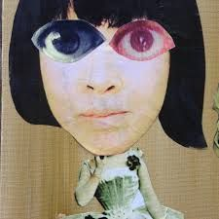
- Chop some faces into sections - for example, hair, eyes, nose, mouth, ears and so on. Mix together features from each face to make a new surreal face.

Key Vocabulary
Background | the space that surrounds the main object
Composition | the way in which different elements of an artwork are combined or arranged
Dada Movement | an art movement formed during the First World War in negative reaction to the horrors of the war. The art produced by dada artists is often ironic and nonsensical in nature.
Mix-Media | composed from a combination of different media or materials.
Photomontage | a combination of several photographs joined together
Surrealist Art | characterised by dream-like visuals, the use of symbolism, and collage images.

What will I know by the end of the unit?
Dada Movement
The Dada movement wasn’t restricted to just the visual mediums, it was incorporated into poetry, musical compositions, literature and theatre.
Photomontages in particular were a popular technique employed by Dadaists, clipping found images from mass media to create a setting that articulated the instability and anger of the world at the time.

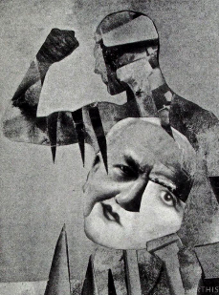
Photomontages were a form of revolution and protest.

As one of the few recognized female members of the movement, Höch provided a unique feminist perspective during a distinctly tumultuous time. In particular, much of her work offered a critique on how society viewed and treated women.

Artist: Hannah Höch (1889 – 1978)
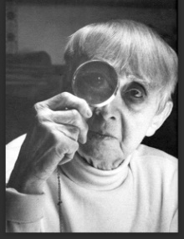
- Hannah Höch is from Germany
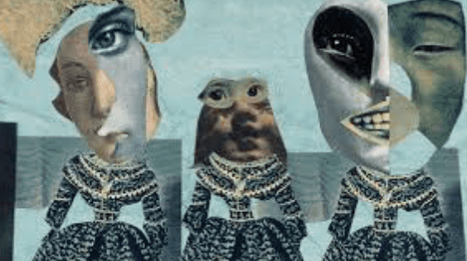
- Höch was known for photomontages (a form she helped pioneer)
- Höch was influenced by Surrealistic Art.
- Höch faced countless obstacles as a boundary-pushing female artist in the 1920s—not least of which was blatant disregard from the bulk of her male colleagues. But Höch never bowed to belittlement. Instead, she forged her own artistic path that

