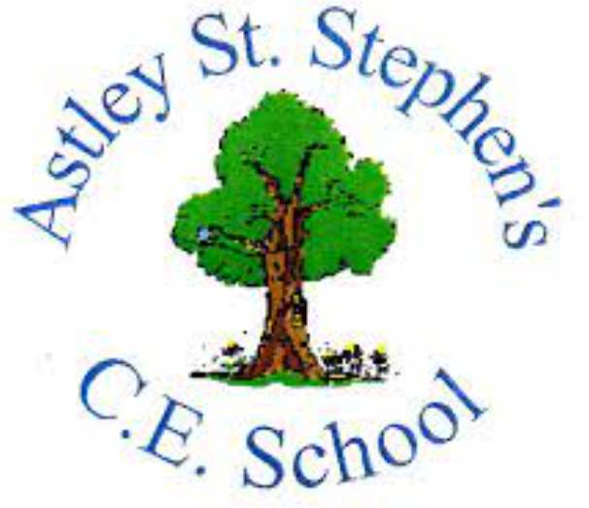 | Art
 | Autumn Term | Year 5 | Area of Study: Painting
What should I already know?
- The names of all primary and secondary colours and how to mix primary colours to make secondary colours.
- Not all artwork is made up of fine detail— different marks, used together, can come together to create an image.
- You can change the texture of paint by adding things
Key skills
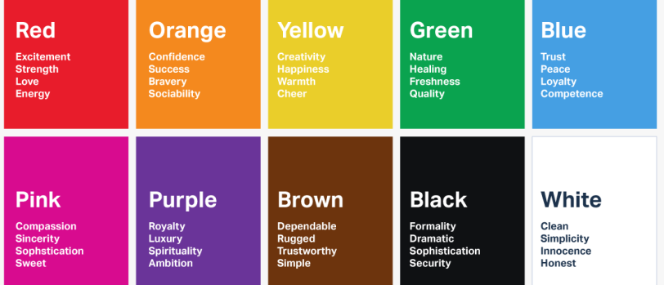
Use colour to express moods
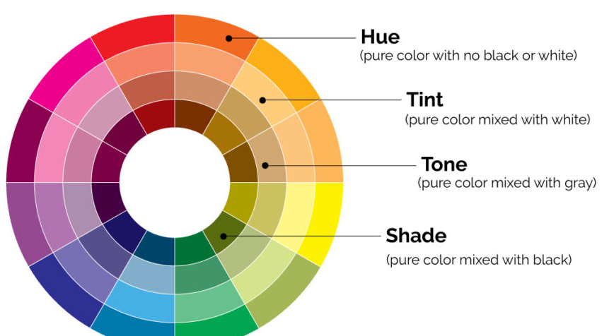
Create Hues, tints, tones, shade in my art
Key Vocabulary
Blend | Mixing two or more colours to create a gradual change.
Complementary Colours | Colours that are directly opposite  each other on a colour wheel
Gradient | A blend of two or more colours or  of two different shades of the  same colour.
Harmonious Colours | Colours that are next to each other  on the colour wheel
Tonal Scale | A scale of different tones of the  same colour from light to dark.

What will I know by the end of the unit?
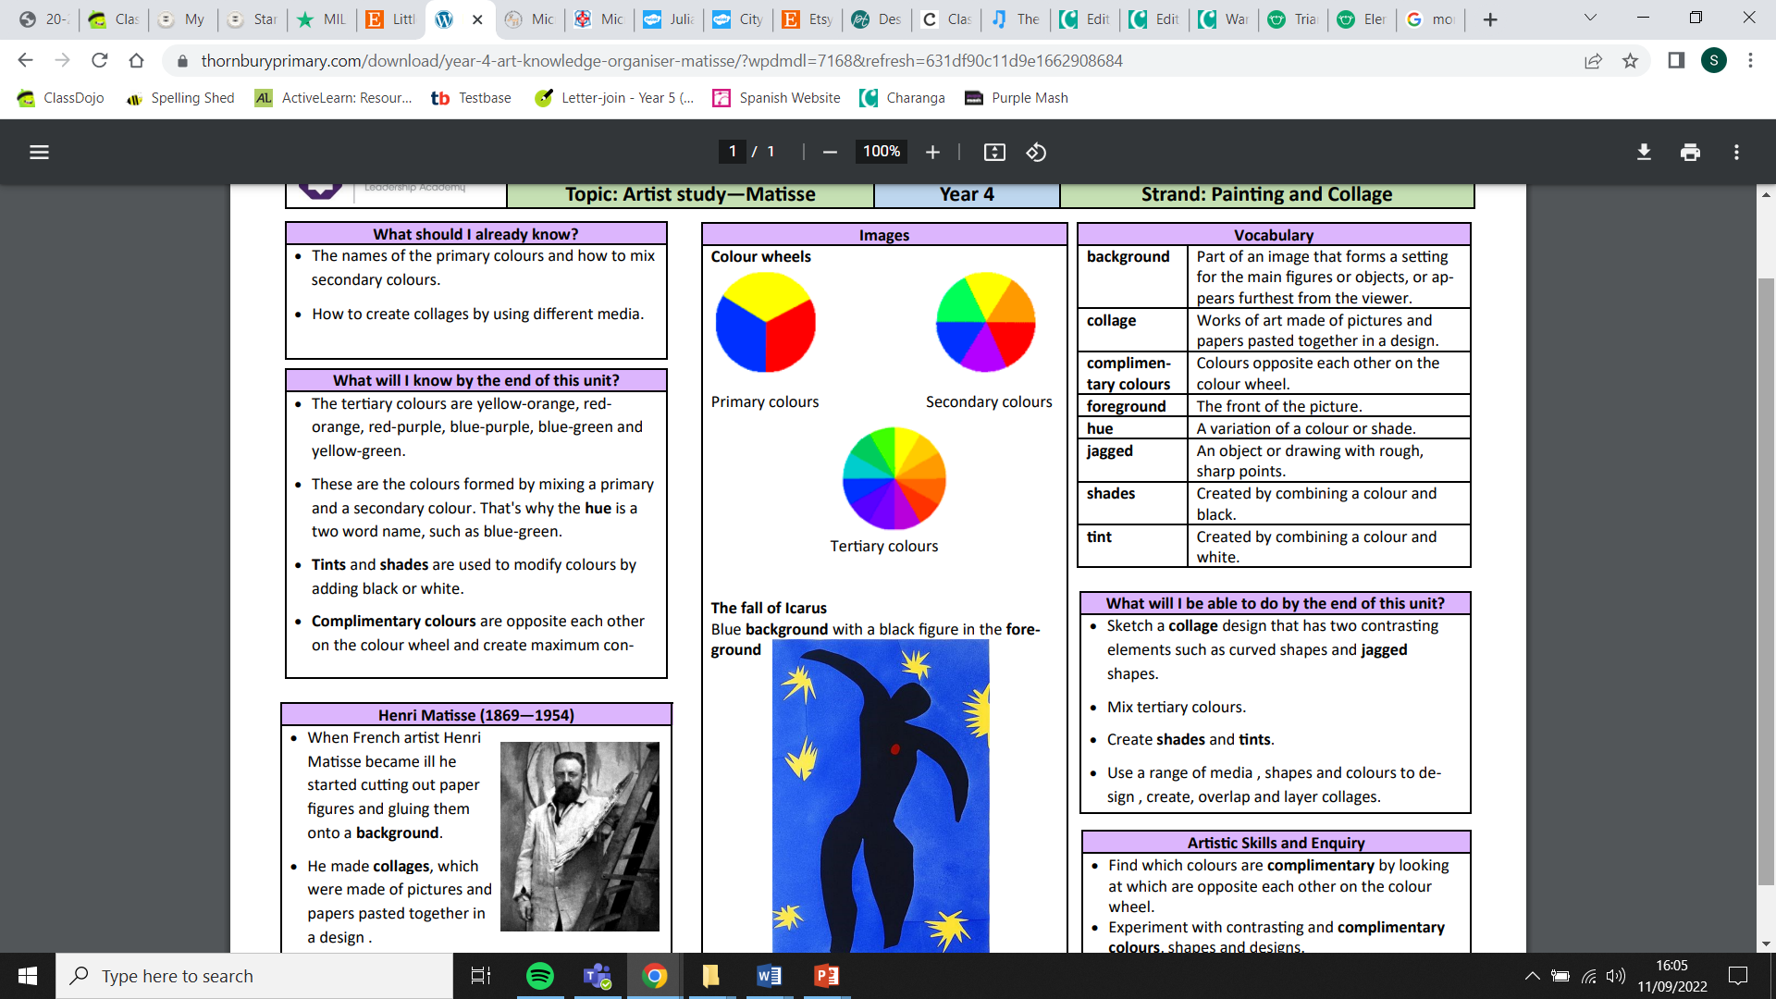
Colour Wheels:
Tertiary colours are yellow-orange, red-orange, red-purple, blue-purple, blue-green and yellow-green.
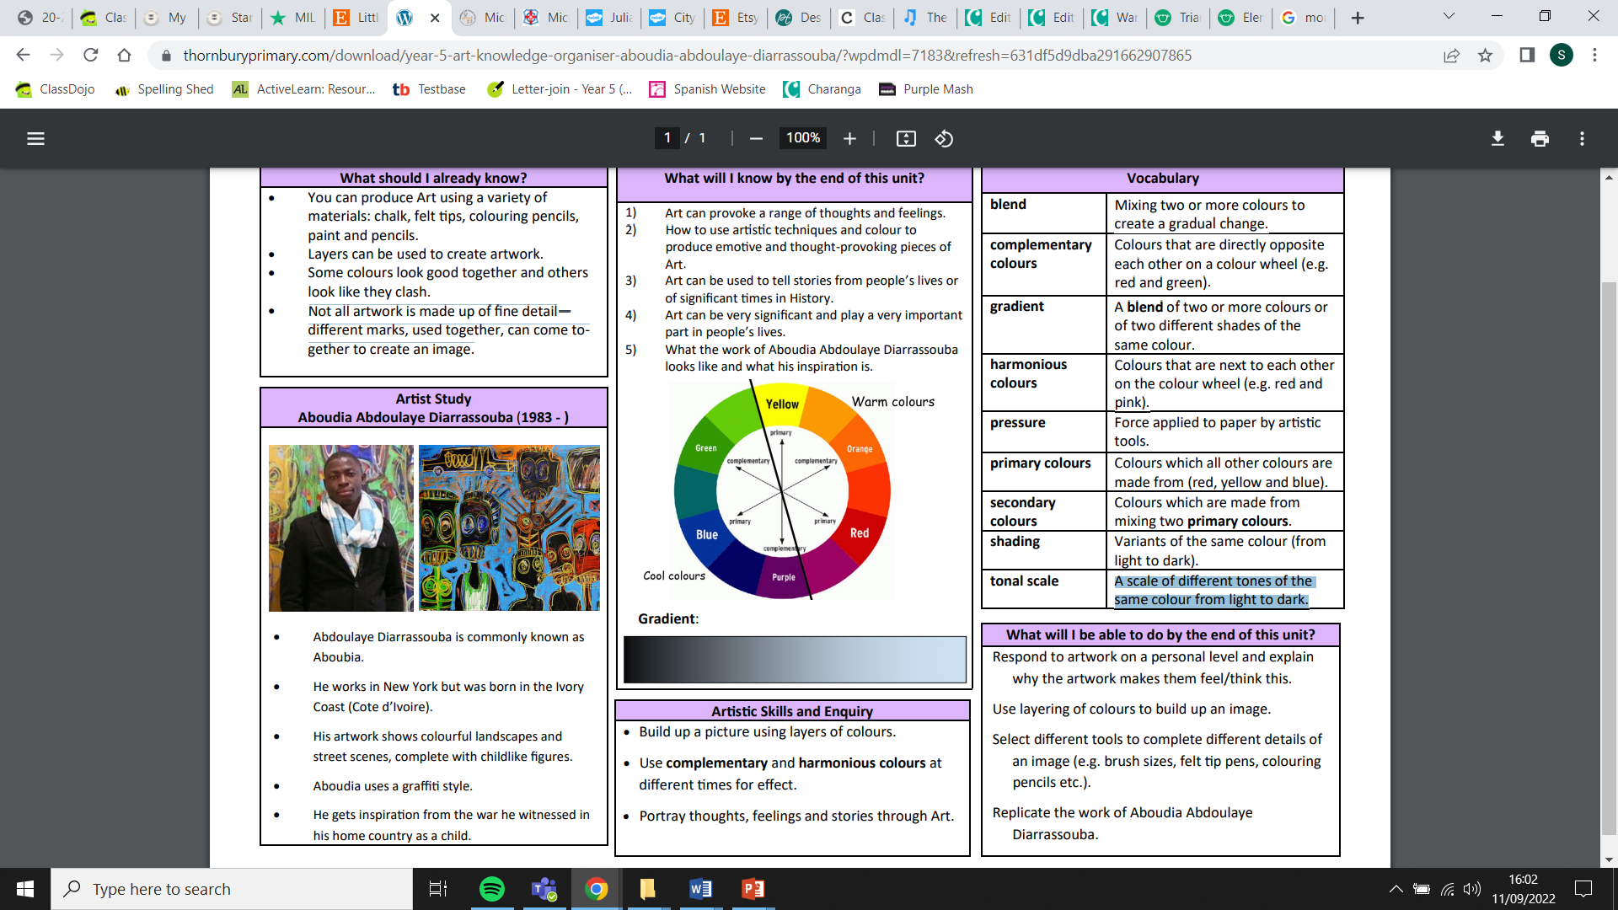
Some colours look good together and others look like they clash.

Know how to make a Gradient.

Artist: Claude Monet (1840 - 1926)
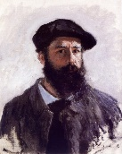
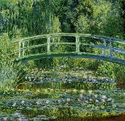
- Claude Monet was from France
- Monet painted using small, quick brushstrokes.
- Monet did not try to reproduce a scene in detail but rather attempted to record on the spot impression
- Monet was the initiator and leader of the Impressionist style.

