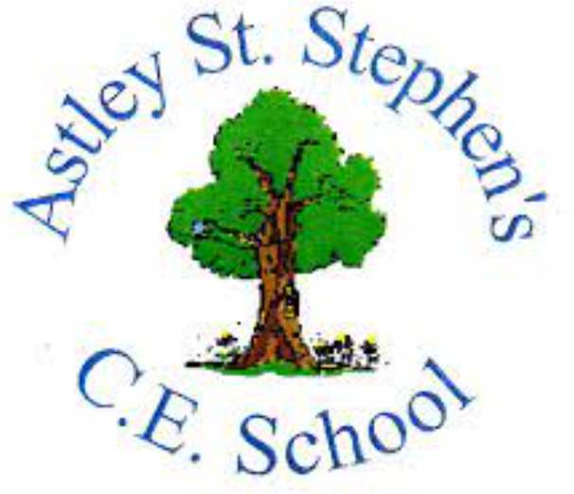 | Art
 | Spring Term | Year 5 | Area of Study: Printing
What should I already know?
- Relief printing can be created using a polystyrene block and can be used repeatedly
- Mono print creates a unique print
- Printing ink in the tray should be spread thin and make a sticky sound
Key skills
Use observational skills, to draw flowers as inspiration.
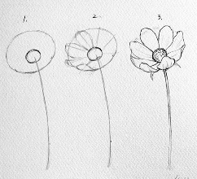
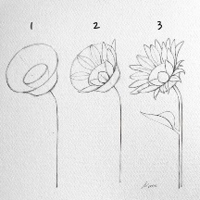

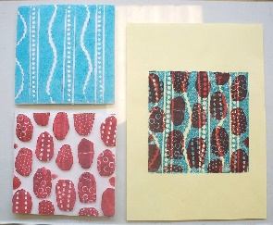
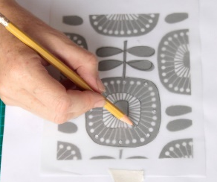
Create detailed relief prints
Layer printing blocks to create interesting designs.
Key Vocabulary
Block printing | Block printing is the process of printing patterns by means of engraved wooden blocks. It is the earliest, simplest and slowest of all methods of textile printing.
Collagraph plate | Printmaking process in which materials are applied to a rigid substrate. The word is derived from the Greek word koll or kolla, meaning glue, and graph, meaning the activity of drawing
Print | An image made by pushing a design onto a surface.
Relief printing | a process consisting of cutting or etching a printing surface in such a way that all that remains of the original surface is the design to be printed

What will I know by the end of the unit?
How to create a collagraph plate:

- Cut up cardboard and stick onto cardboard plate
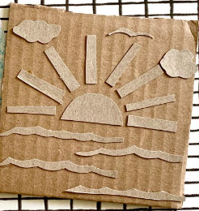
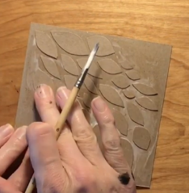

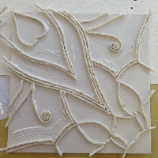
- Glue various types of material to cardboard.
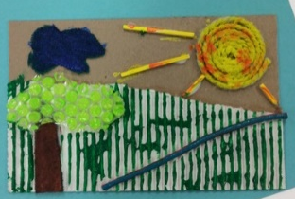

Artist: William Morris (1834-1896)
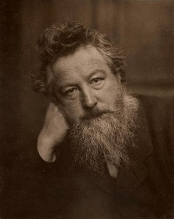
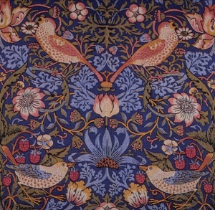
- Morris originally was going to become a priest but decided to devote his life to art instead.
- His career in designing started when he decorated his own house in London.
- William Morris is very famous for his wallpaper designs. He created some beautiful designs, the likes of which had never been used before. In fact, wallpaper before his day was quite plain.
- William Morris, who was also an environmental campaigner, created designs of floral patterns (patterns inspired by flowers and plants) which were repeated many times by block printing.

