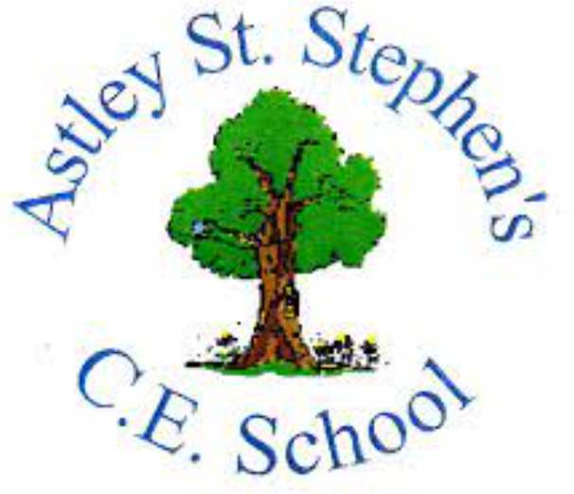 | Art
 | Summer Term | Year 6 | Area of Study: Clay
What should I already know?
• Pinch pots are made from balls of clay that have been pinched into shape.
• Clay can be rolled, kneaded and pinched.
• Patterns and textures can be applied to clay.
- Scoring the surface of clay joins pieces more securely.
Key skills
Use pattern’s Clarice Cliff used in her designs, which will inspire my own decoration design.
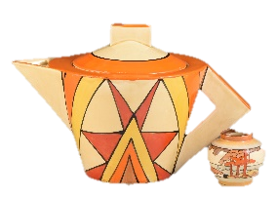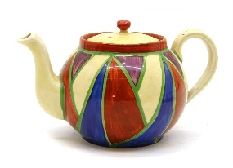
Plan a final piece through drawing and other preparatory work
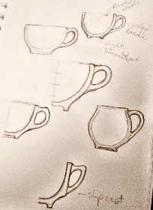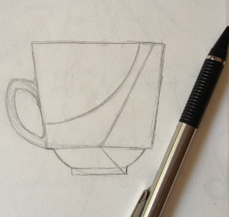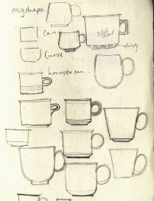

Key Vocabulary
Ceramic | made of clay and permanently hardened by heat.
Coil | A long, thin rope of clay made by rolling is between your hands
Pinch Pot | A bowl made by pinching a sphere of clay
Score | Roughly scratching the surface so it can be joined to another piece of clay
Slab | A flat piece of clay made with your hands or a rolling pin
Slip | Mixture of water and clay, used as a bonding agent.

What will I know by the end of the unit?
How to make a good sized pinch pot:
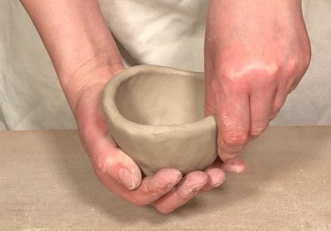

How to add height to the pinch pot:
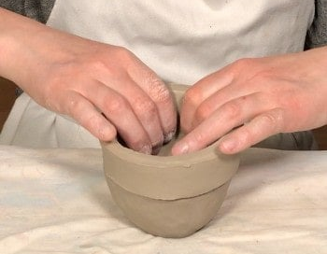

How to add a handle:
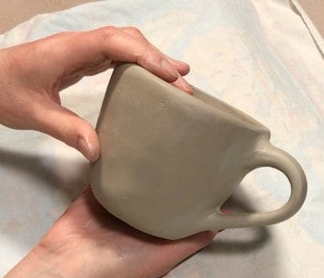

Artist: Clarice Cliff (1899 - 1972)
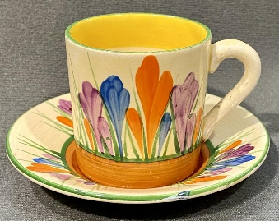
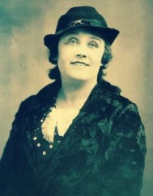
- Born in Stoke-on-Trent
- One of the most influential ceramics artists of the 20th Century
- Clarice developed a new design for pottery called Bizarre
- By 1929, she began to sell her work, which continued to be inspired by shapes, around the world.

