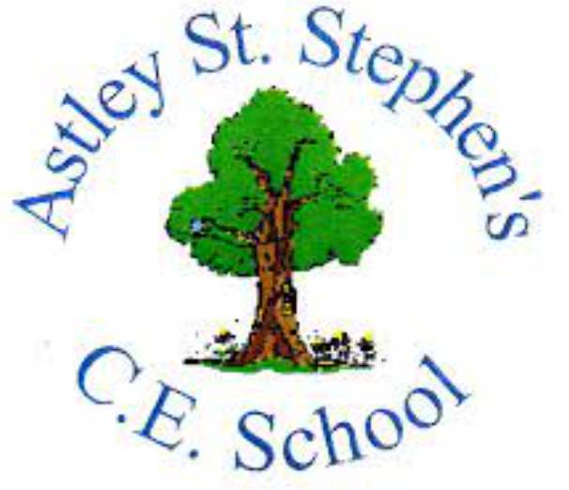 | Art
 | Autumn Term | Year 6 | Area of Study: Drawing
What should I already know?
- A landscape is a picture of a place
- Pencils come in different grades which impact on shading
- Hatching and cross-hatching are shading techniques using lines
- Light sources effect the strength of shading
Key skills
Be able to add detail to a city scape:

Use a variety of shading techniques:
Key Vocabulary
Cityscape | The visual appearance of a city or urban area; a city landscape
Horizon | The point in the distance where the land meets the sky
One point perspective | The view of an image from ‘front on’
Orthogonal line | Lines that move away from us
Perspective | A view point, showing what we see in 3D as a 2D image
Shading | The darkening of a drawing with lines or blocks of colour, used to create the illusion of depth, or make an object three-dimensional
Vanishing Point | The spot on the horizon where all the parallel lines recede to

Artist: Stephen Wiltshire (1974)
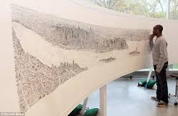
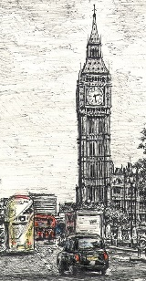
- Stephen Wiltshire MBE is a British architectural artist.
- As a child he didn’t speak and found it difficult to relate to others. By the age of three, he was diagnosed with autism.
- He is extremely talented at creating realistic and lifelike cityscapes even when he may have only seen them for a short period of time.
- His work has gained worldwide popularity.
What will I know by the end of the unit?
The stages of drawing from one-point perspective:

The stages of drawing 3D shapes from one-point perspective:

