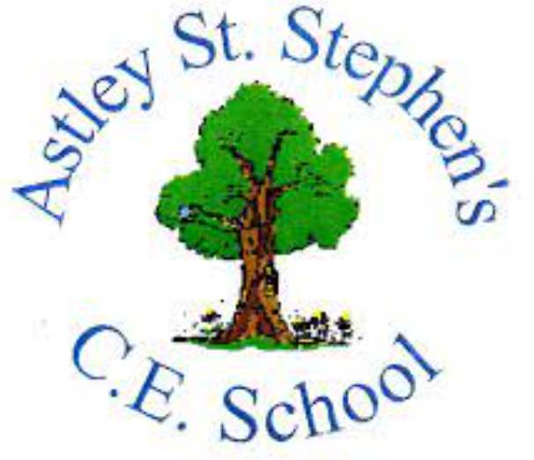 | Art
 | Spring Term | Year 6 | Area of Study: Textiles
What should I already know?
- Sew using different stitches: running, stem, chain, split
- Layering material on top of my base layer to add interest
- Adding embellishments onto sewing
Key skills
Create a mood board
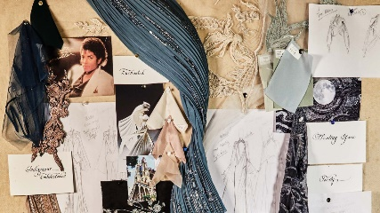

Design a fashion look
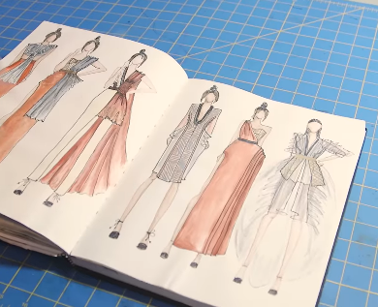

Key Vocabulary
Controversial | Causing a lot of angry public discussion and disagreement.
Garment | Pieces of clothing.
Highstreet | Clothes that can be bought in ordinary shops in ordinary cities and towns
Kilts | Skirts made of tartan cloth that reach the knee. Traditionally worn by Scottish men.
Punk | A type of loud and aggressive rock music that was popular in the late 1970s and early 1980s.
Runway | Same as ‘catwalk’  A long, narrow stage that models walk along in a fashion show
Slogan | A word or phrase that is easy to remember. They are often used in advertising or by political parties to attract attention or to suggest an idea quickly.

What will I know by the end of the unit?
Vivienne Westwood took her inspiration from many different things, each of these inspiring a new collection.
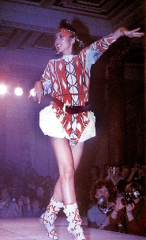
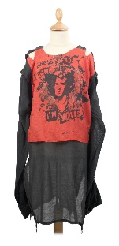
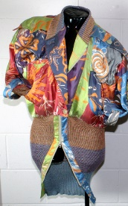
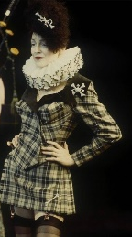
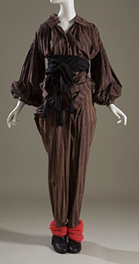
1976: Punk Rock 1981: Pirate 1981: Mattise & Picaso
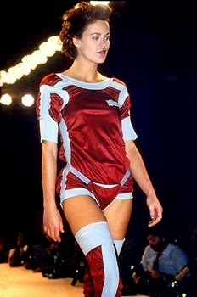
1983: challenging 1984: Toyko’s 1987: Tudor and gender stereotypes Neon signs Jacobean’s

Artist: Vivienne Westwood (1941-2022)
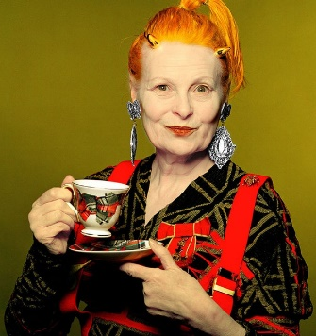
- Vivienne Westwood was born in Derbyshire, England
- When Vivienne first started making clothes, it was very different to the fashion of the 1960’s
- In 1971, she opened a shop in London to sell creative punk pieces – one of the first fashion houses to make slogan t-shirts.
- Some of her fashion pieces were highly controversial
- Garments were layered and combined with tartan kilts – a theme in many of their fashion collections.
- Over time, Dame Vivienne became one of the most iconic fashion designers in history.

