Astley St Stephen’s CE Primary School Geography Overview

 | Autumn Term | Spring Term | Summer Term
Year 1 | 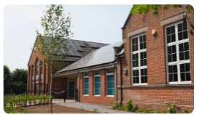  My School | 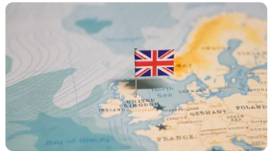  The United Kingdom | 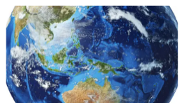  The World
Year 2 | 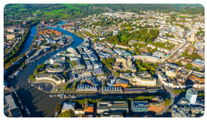  Where We Live | 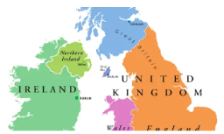  The United Kingdom | 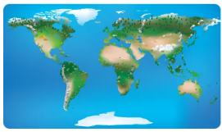  The World
Year 3 | Italy  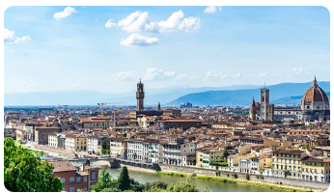 | Settlements  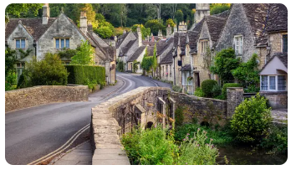 | Biomes  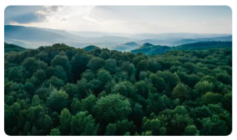
Year 4 | 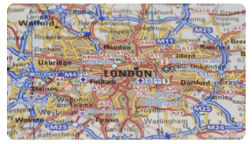  The United Kingdom | 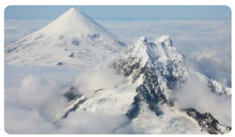  Volcanoes, Mountains and Earthquakes | Europe  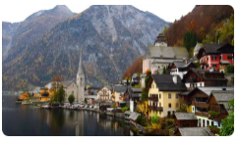
Year 5 | 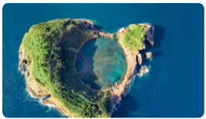  Our Blue Planet | Our Local Area  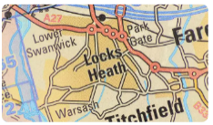 | 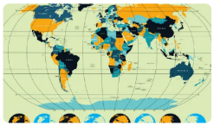  Our Connected World
Year 6 | 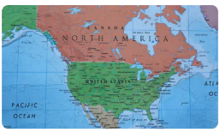  North America | 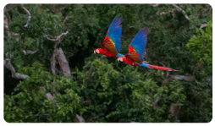  The Amazon Rainforest | My Place  

Send- targets on the learning plan
PPG- how is the grid coming on
Pupil Progress- other children not reaching targets
3 kids for accelerated progress

